PAGE 1 — SERVER MANAGER
Topic: Open Server Manager
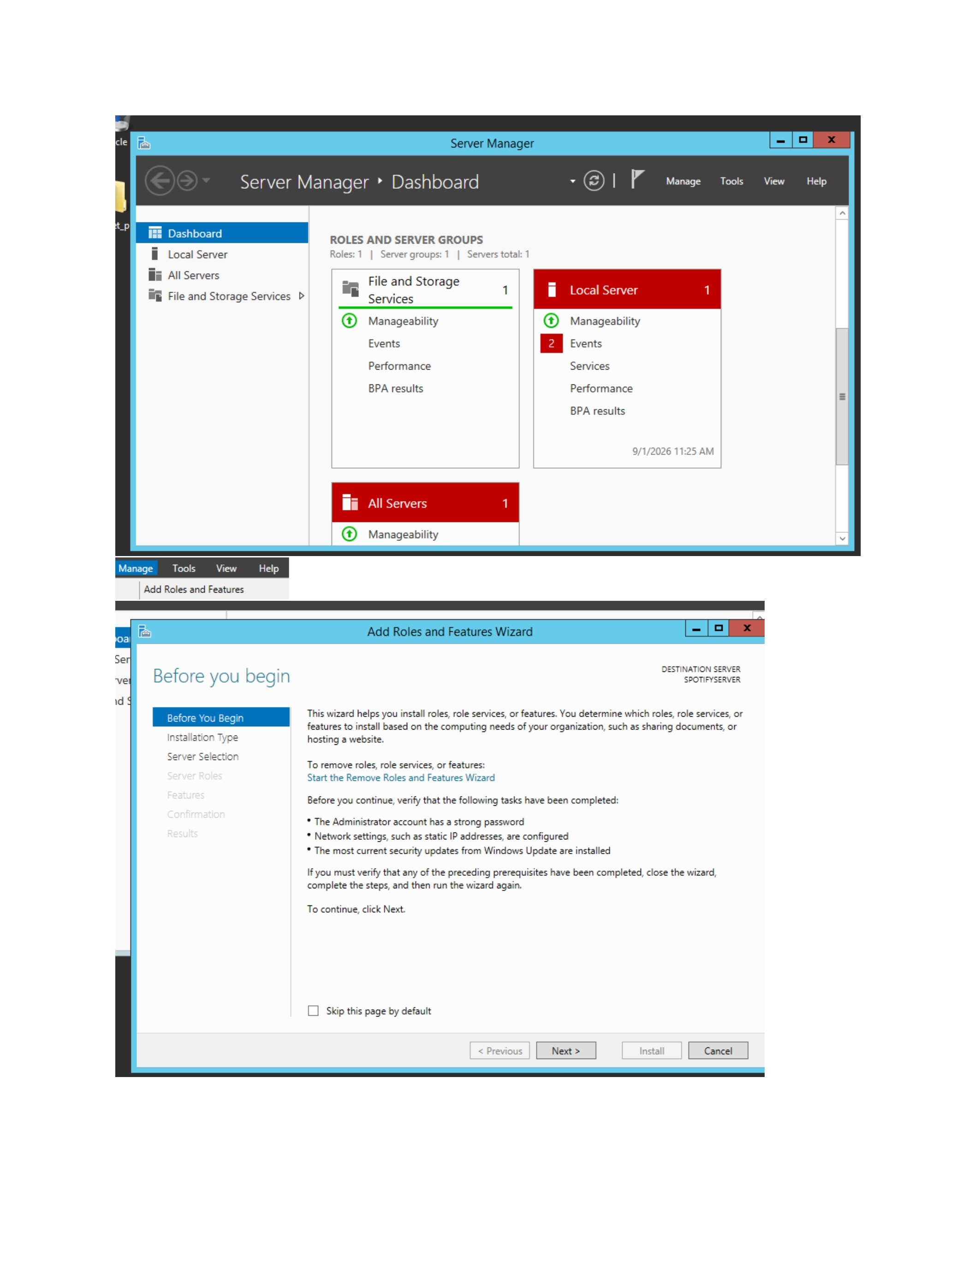
What I did: I opened Server Manager and reviewed the current server roles and status.
Explanation: This is the starting point for configuring the Windows Server environment.

PAGE 2 — ACTIVE DIRECTORY DOMAIN SERVICES
Topic: Start Add Roles and Features
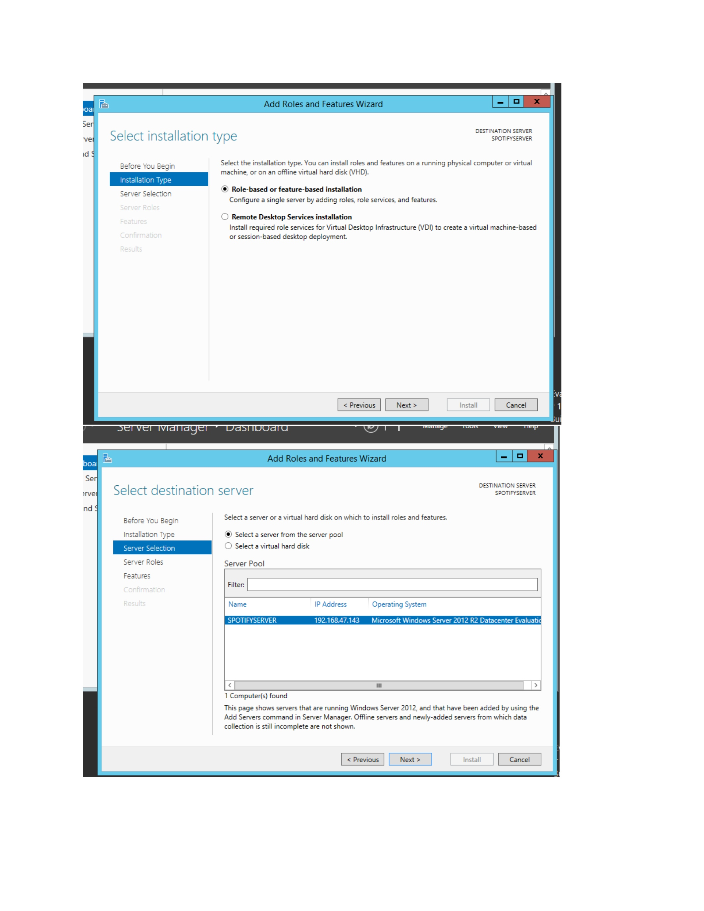
What I did: I opened the Add Roles and Features wizard from Server Manager.
Explanation: The wizard is used to add the required server role.

PAGE 3 — ACTIVE DIRECTORY DOMAIN SERVICES
Topic: Review installation requirements
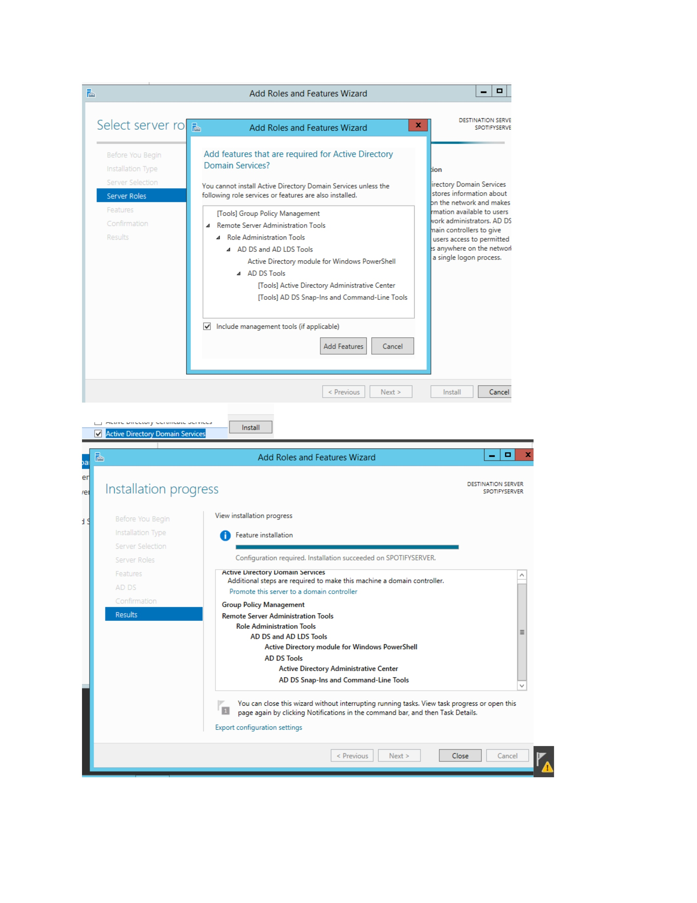
What I did: I reviewed the information and requirements shown before continuing with the role installation.
Explanation: This confirms the prerequisites before selecting the server role.

PAGE 4 — ACTIVE DIRECTORY DOMAIN SERVICES
Topic: Select the destination server
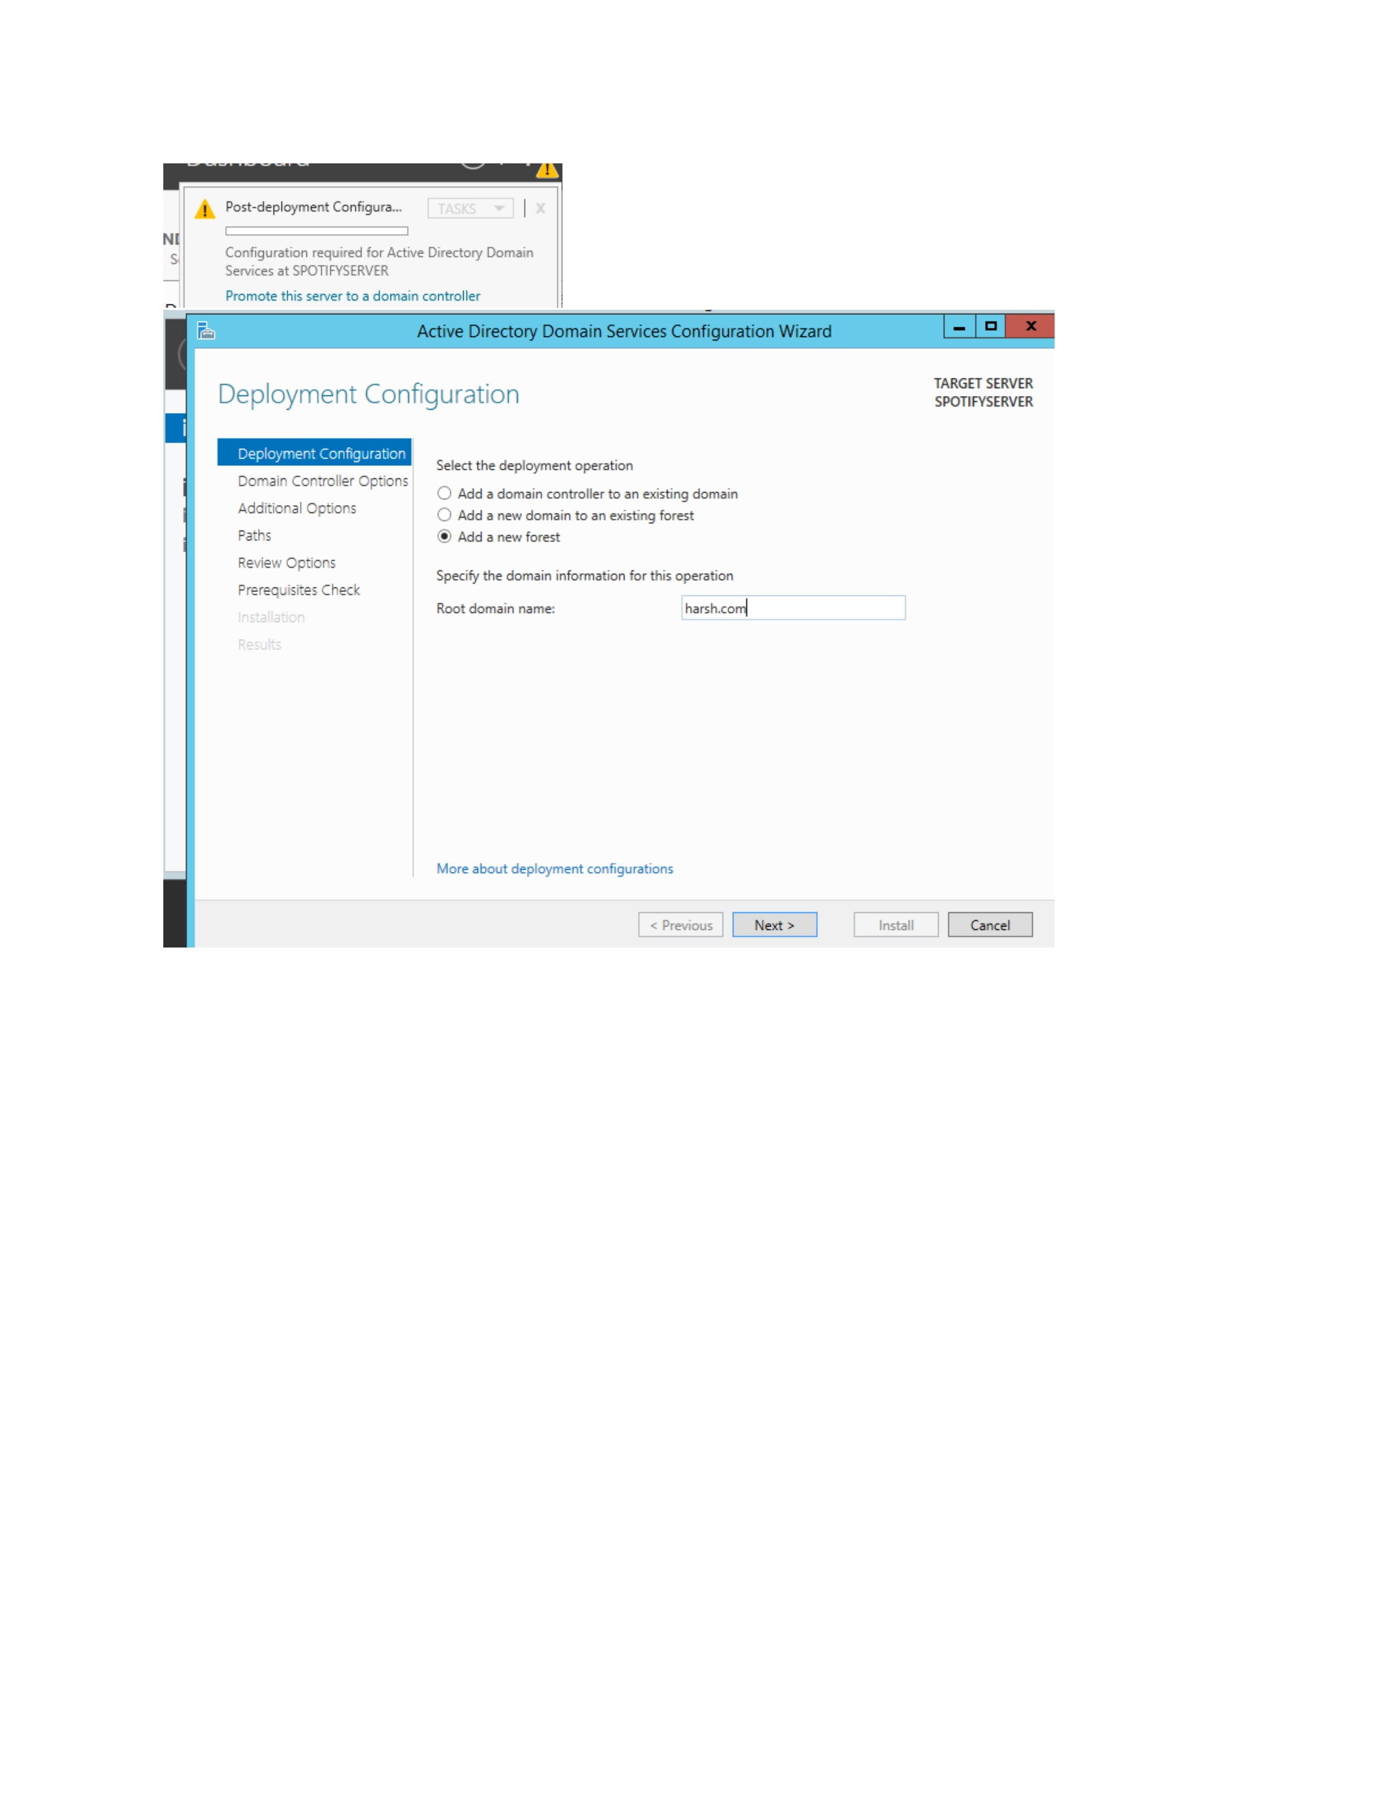
What I did: I selected the target server in the server-selection step.
Explanation: The selected server is the system on which the Active Directory role will be installed.

PAGE 5 — ACTIVE DIRECTORY DOMAIN SERVICES
Topic: Select the server role
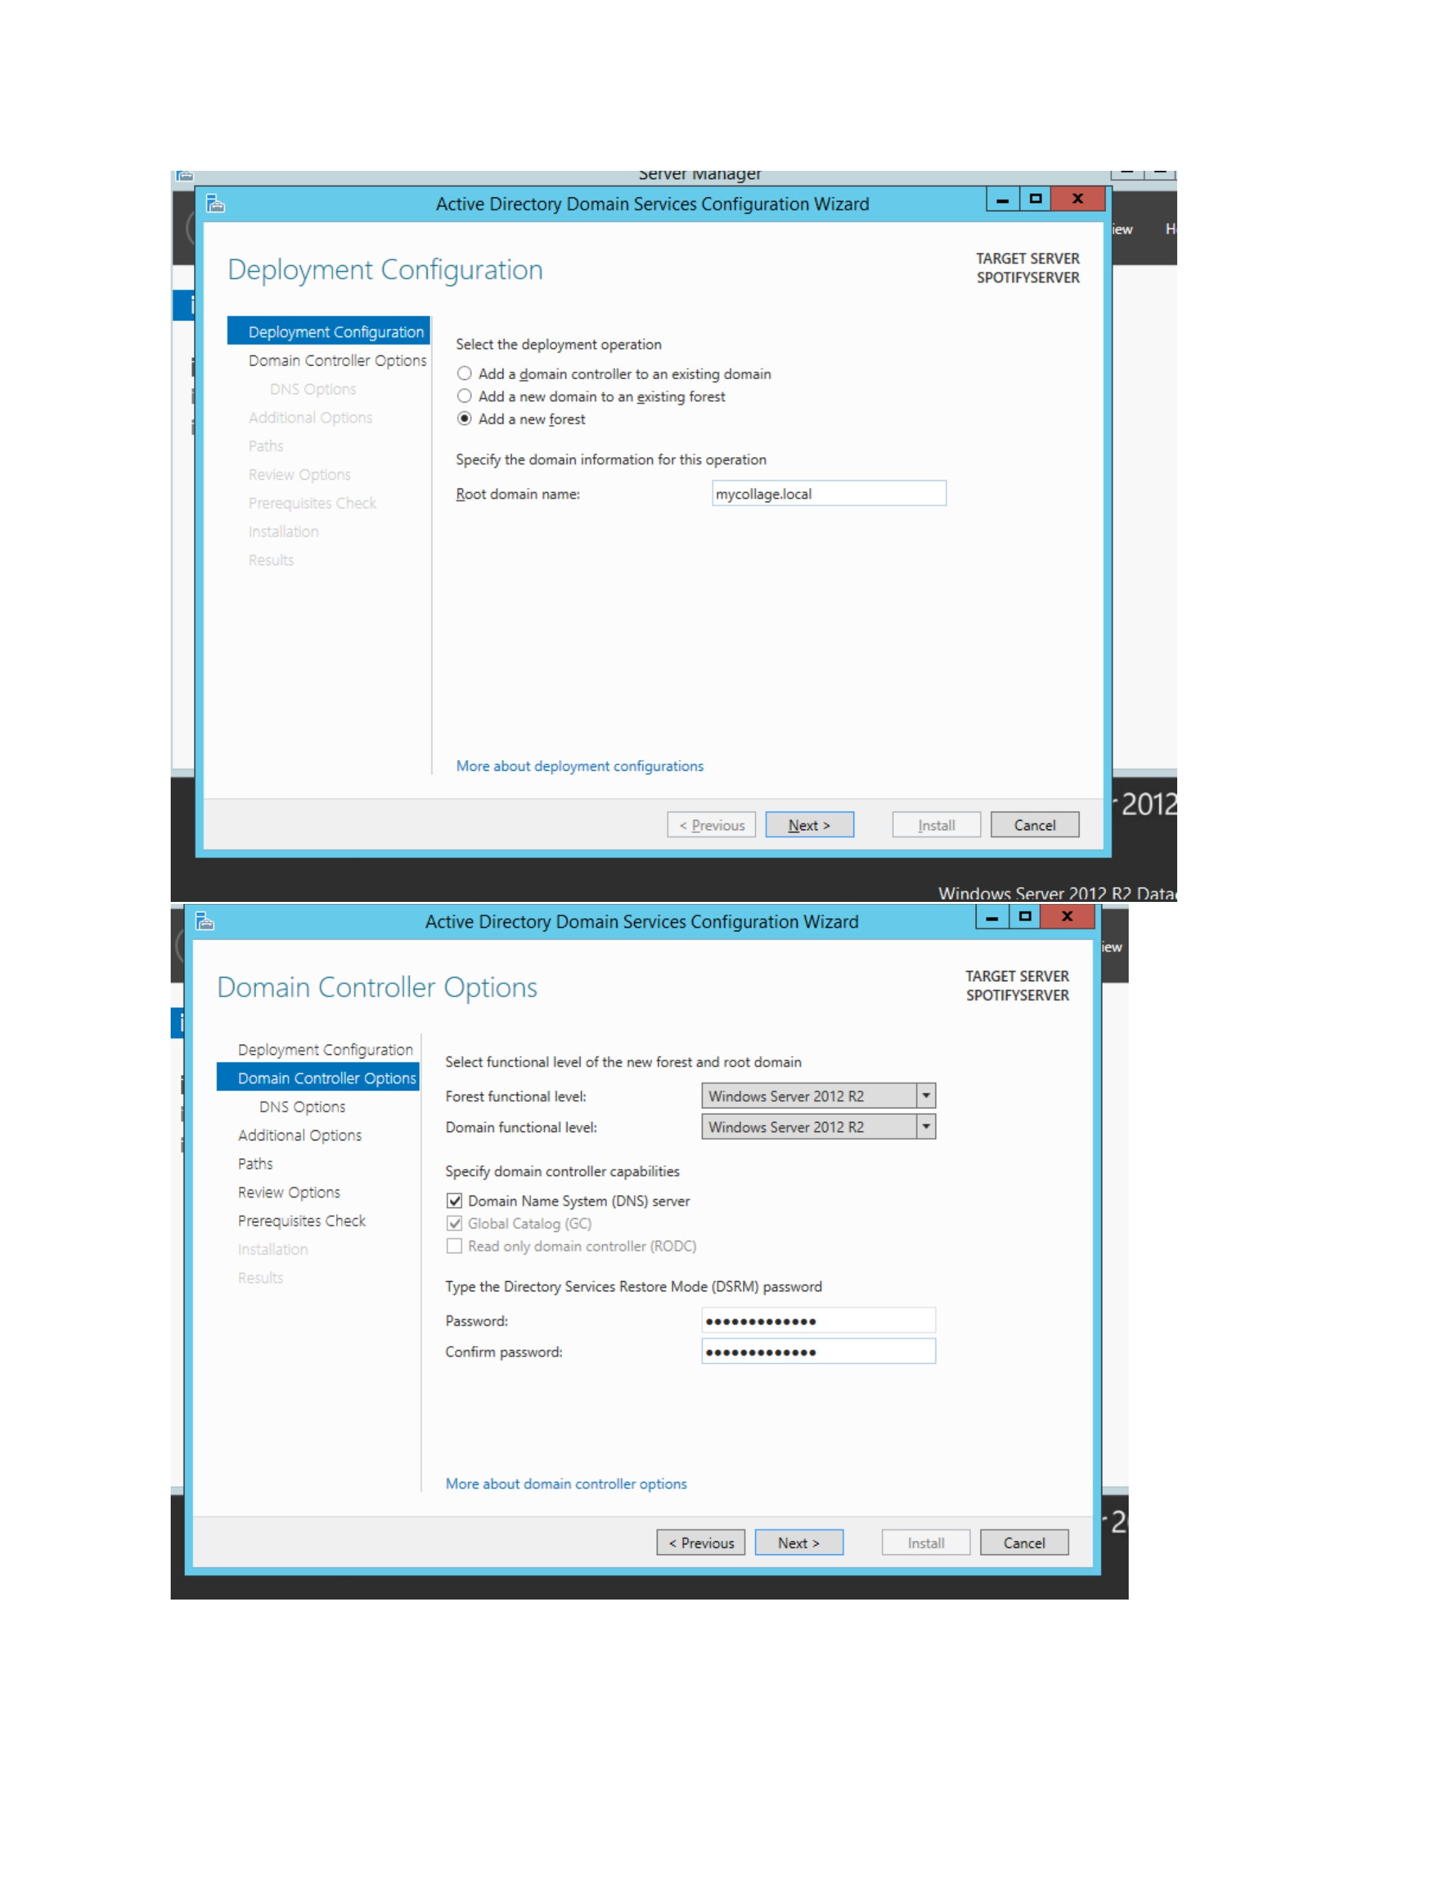
What I did: I selected Active Directory Domain Services in the Server Roles list.
Explanation: This adds the AD DS role to the server configuration.

PAGE 6 — ACTIVE DIRECTORY DOMAIN SERVICES
Topic: Review required features
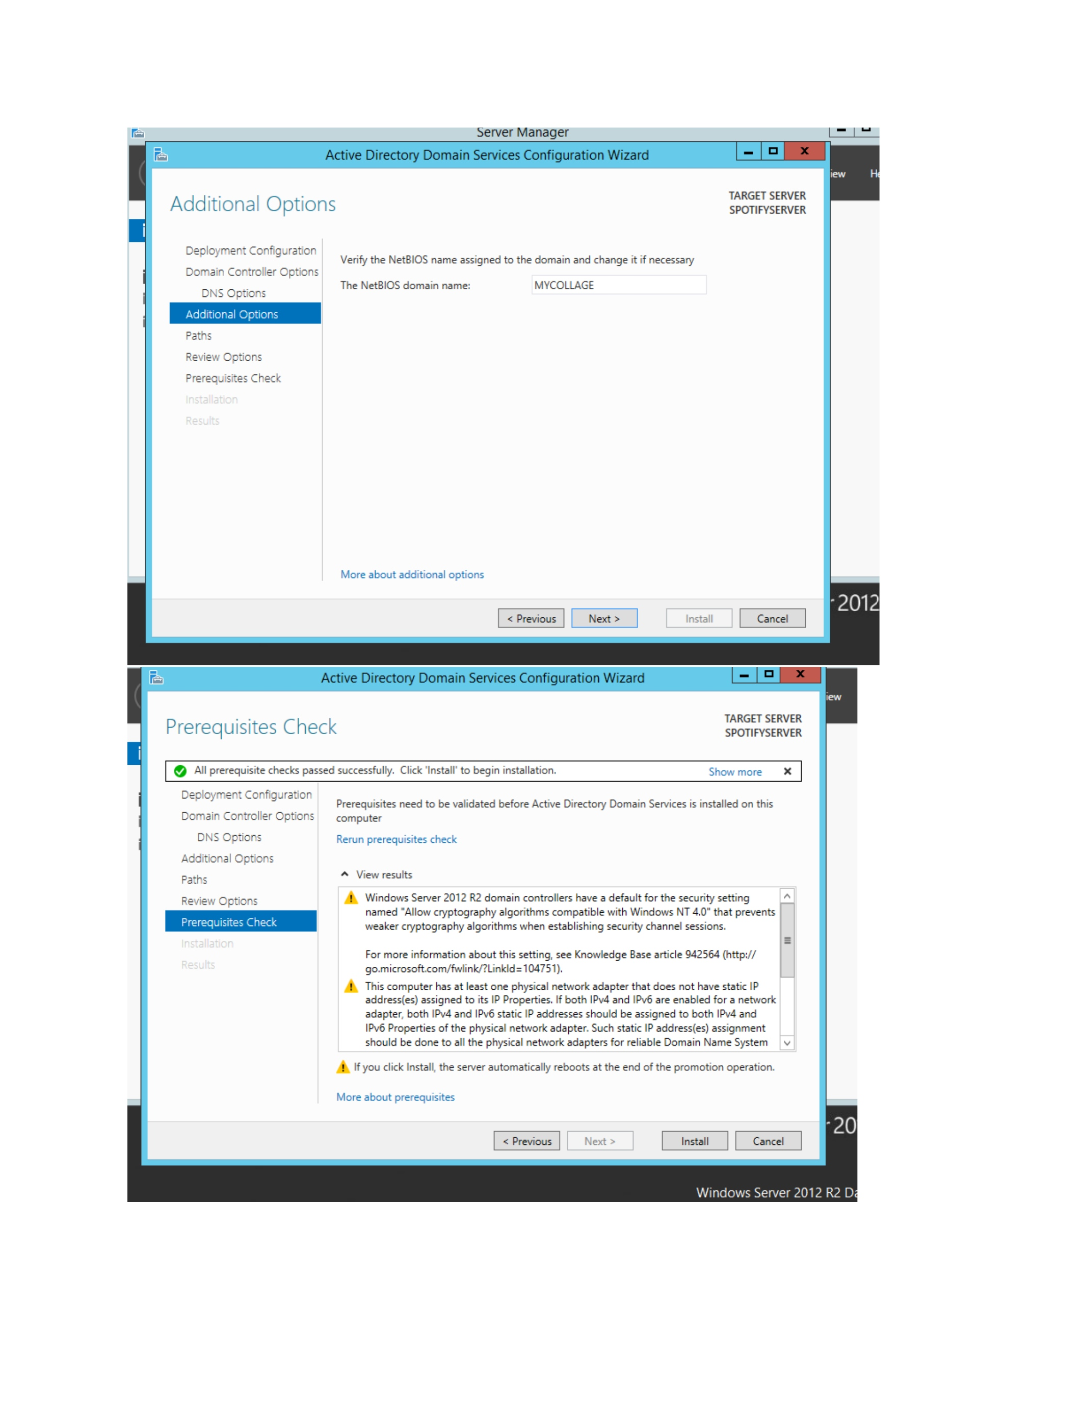
What I did: I reviewed the additional features and management tools required for the selected role.
Explanation: The wizard shows the components that will be installed along with AD DS.

PAGE 7 — ACTIVE DIRECTORY DOMAIN SERVICES
Topic: Confirm installation
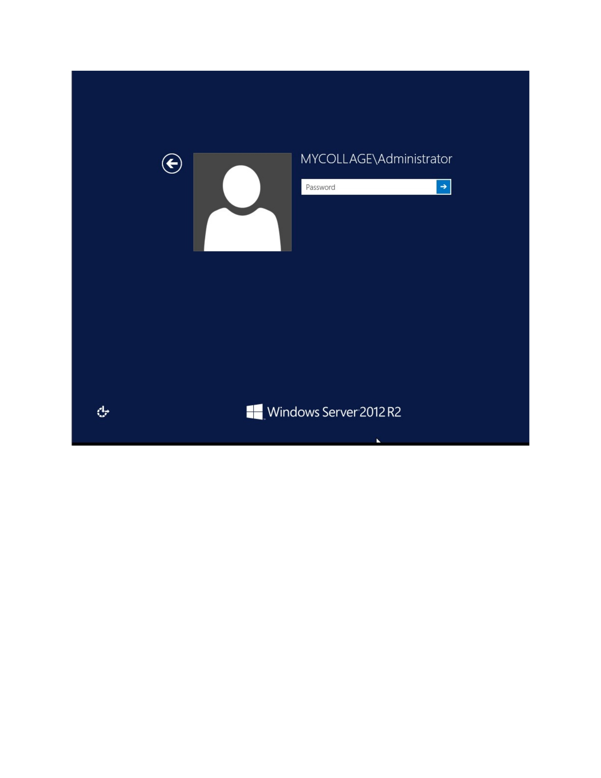
What I did: I reviewed the installation summary and started the role installation.
Explanation: The installation page confirms the selected role and features before applying the changes.

PAGE 8 — WINDOWS SERVER
Topic: Log in to the server
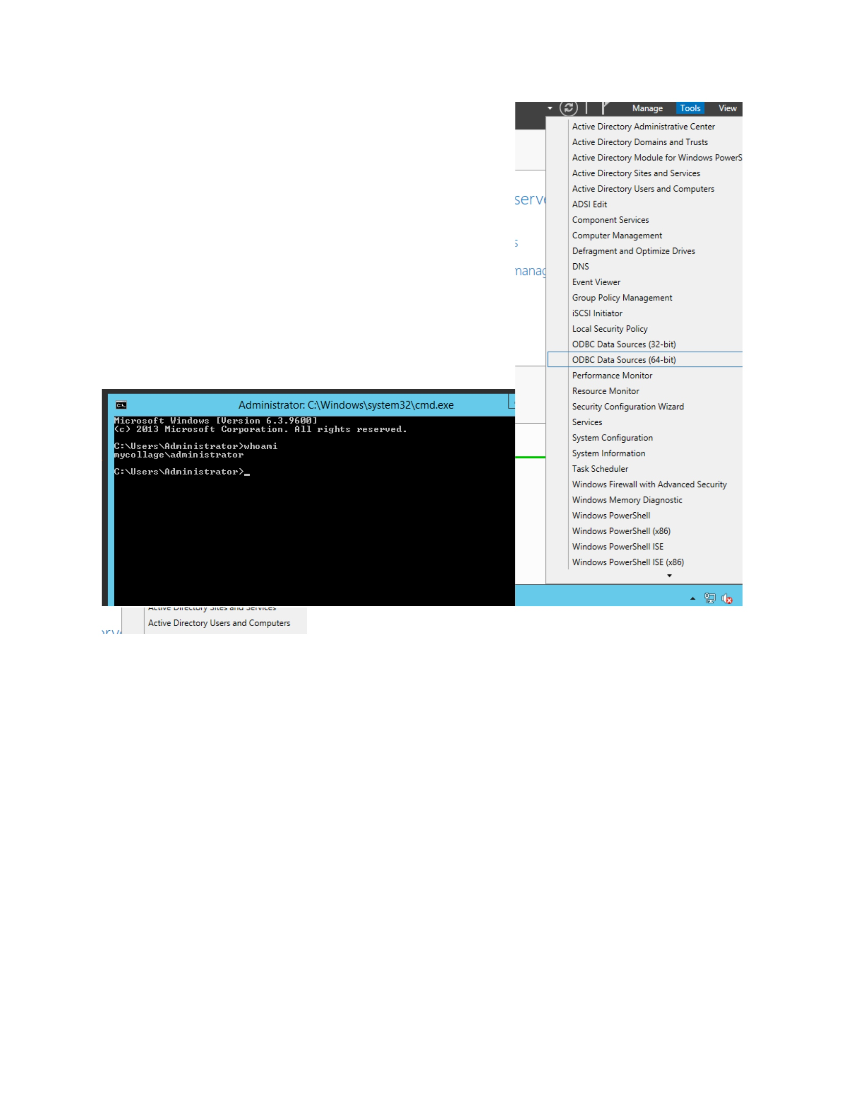
What I did: I logged in to the Windows Server system to continue the Active Directory configuration.
Explanation: The server desktop is now available for the next configuration steps.

PAGE 9 — ACTIVE DIRECTORY
Topic: Open the management tools
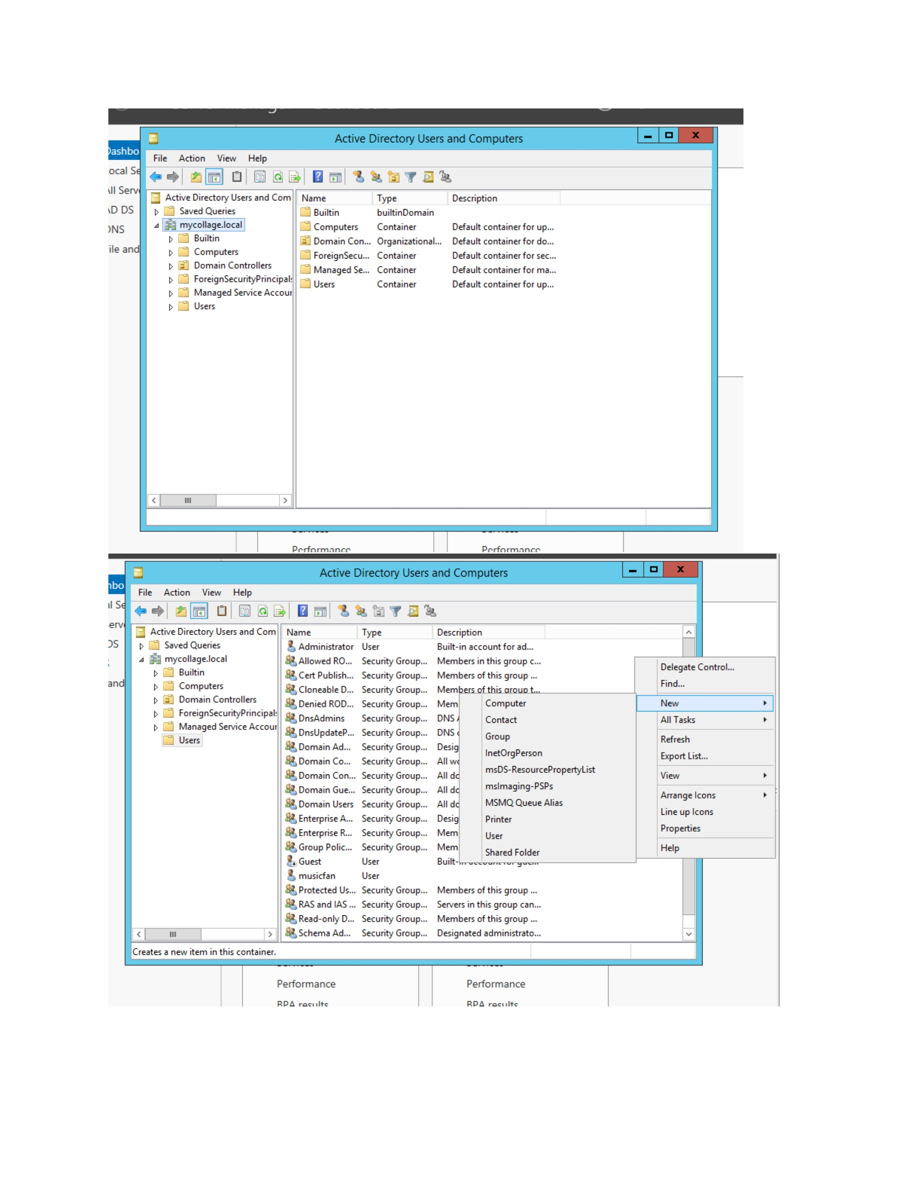
What I did: I opened the Active Directory management environment and reviewed the available objects.
Explanation: This provides access to the domain, users, groups, and computer objects.

PAGE 10 — ACTIVE DIRECTORY USERS
Topic: Create a new user
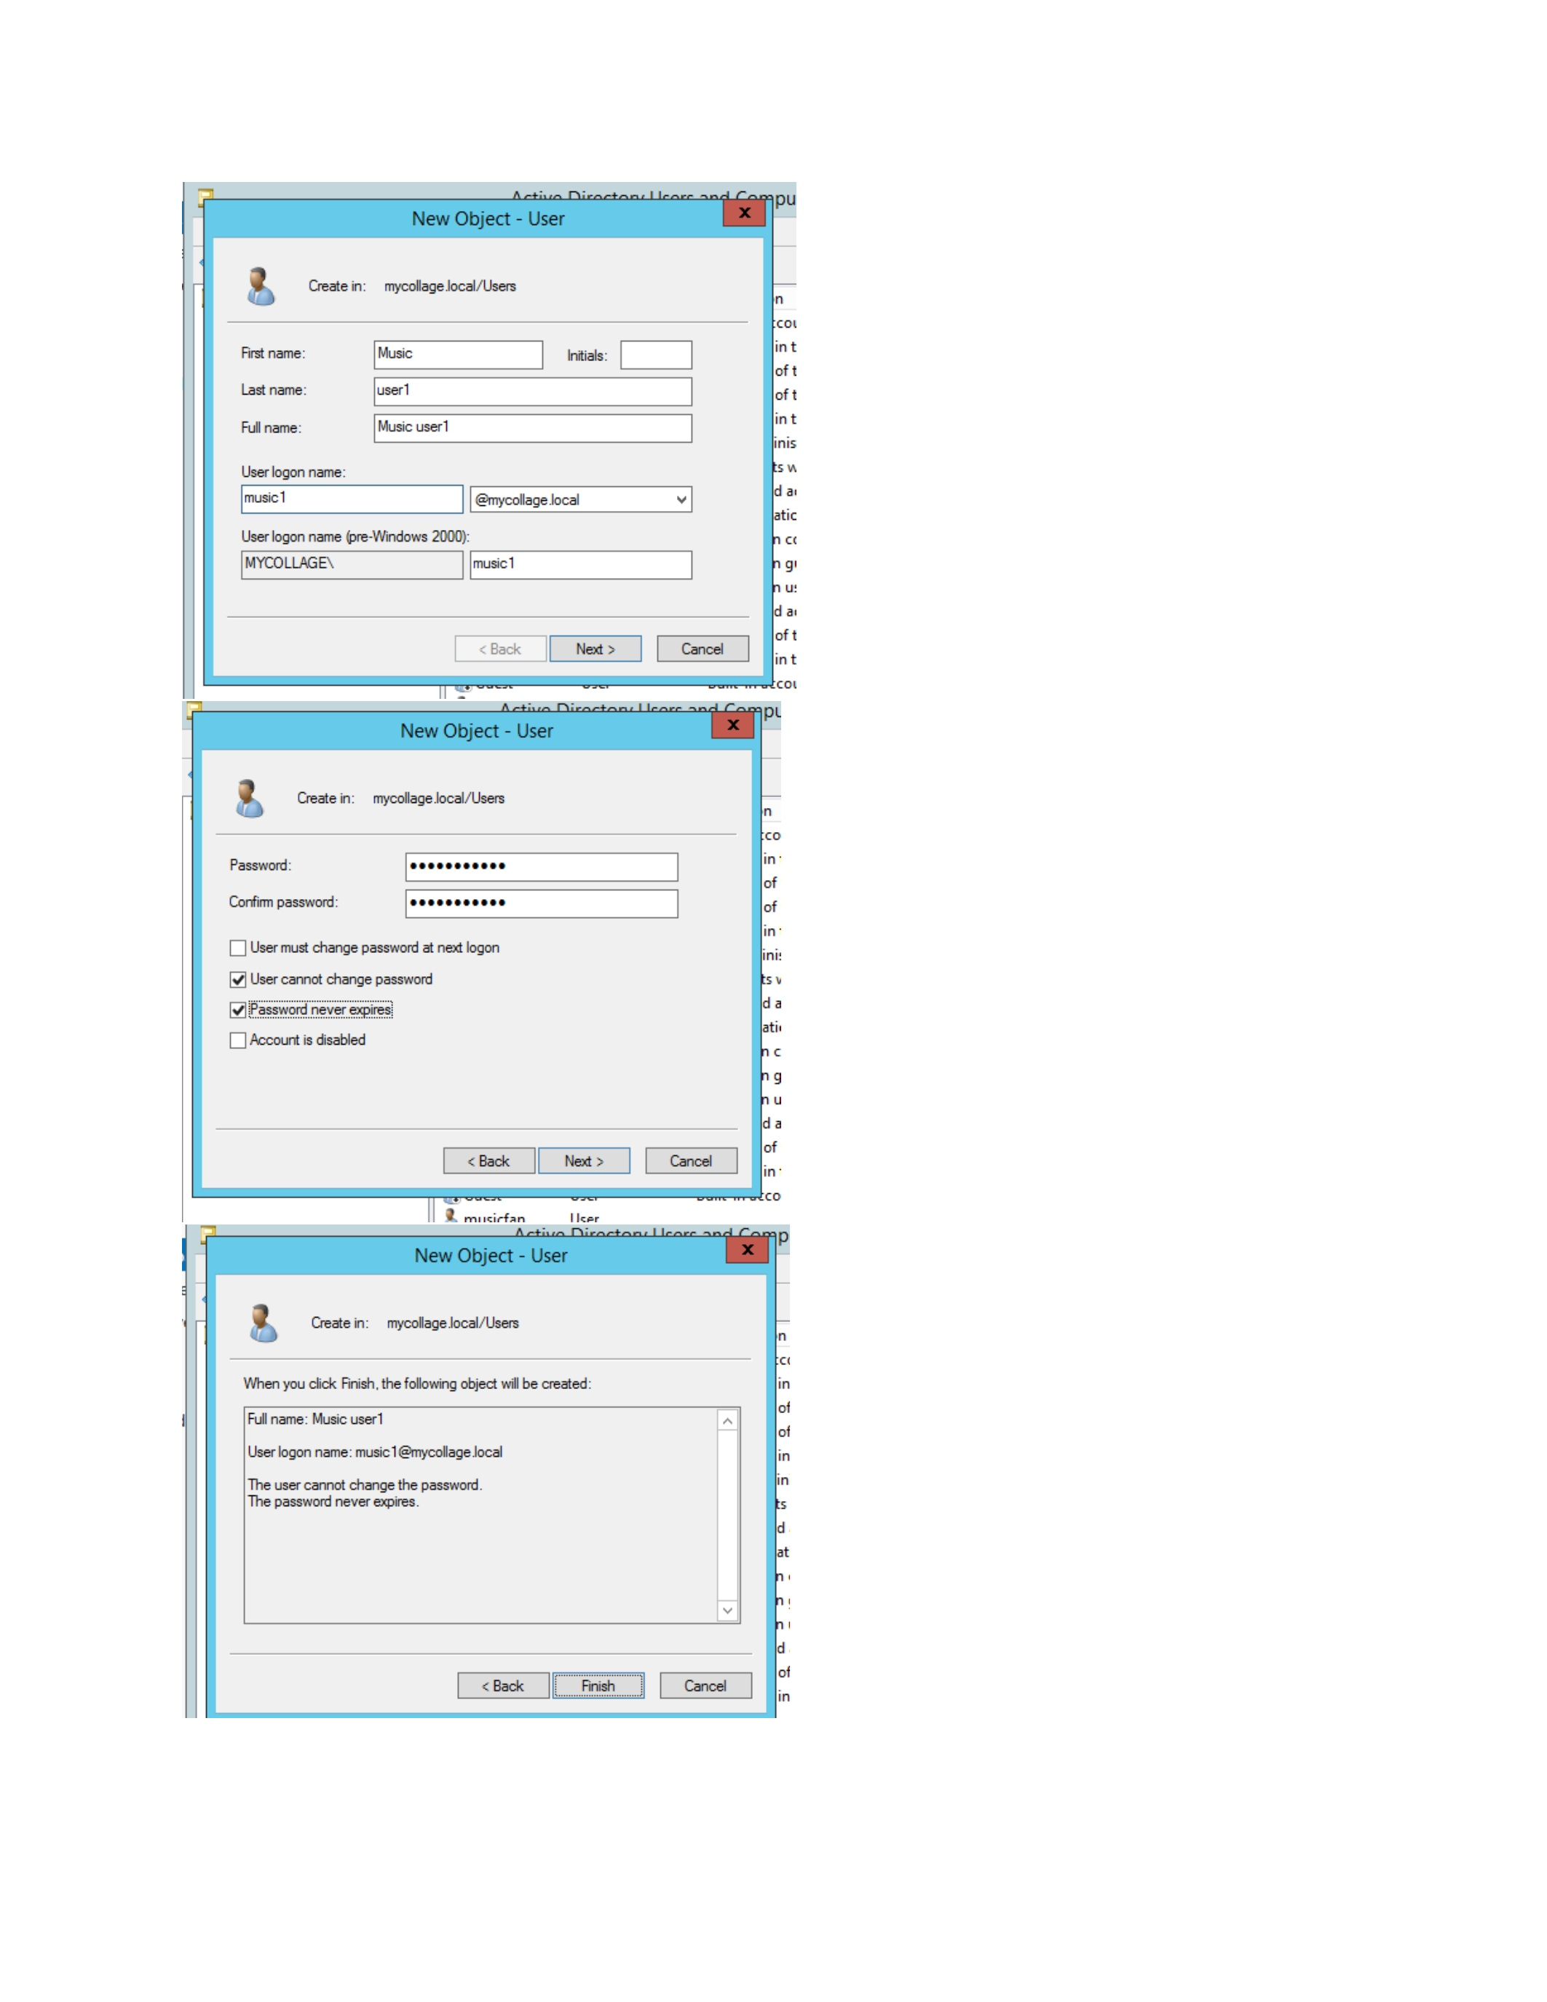
What I did: I opened the New User dialog and entered the required user information.
Explanation: The dialog is used to create a new domain user account.

PAGE 11 — ACTIVE DIRECTORY USERS
Topic: Set user account options
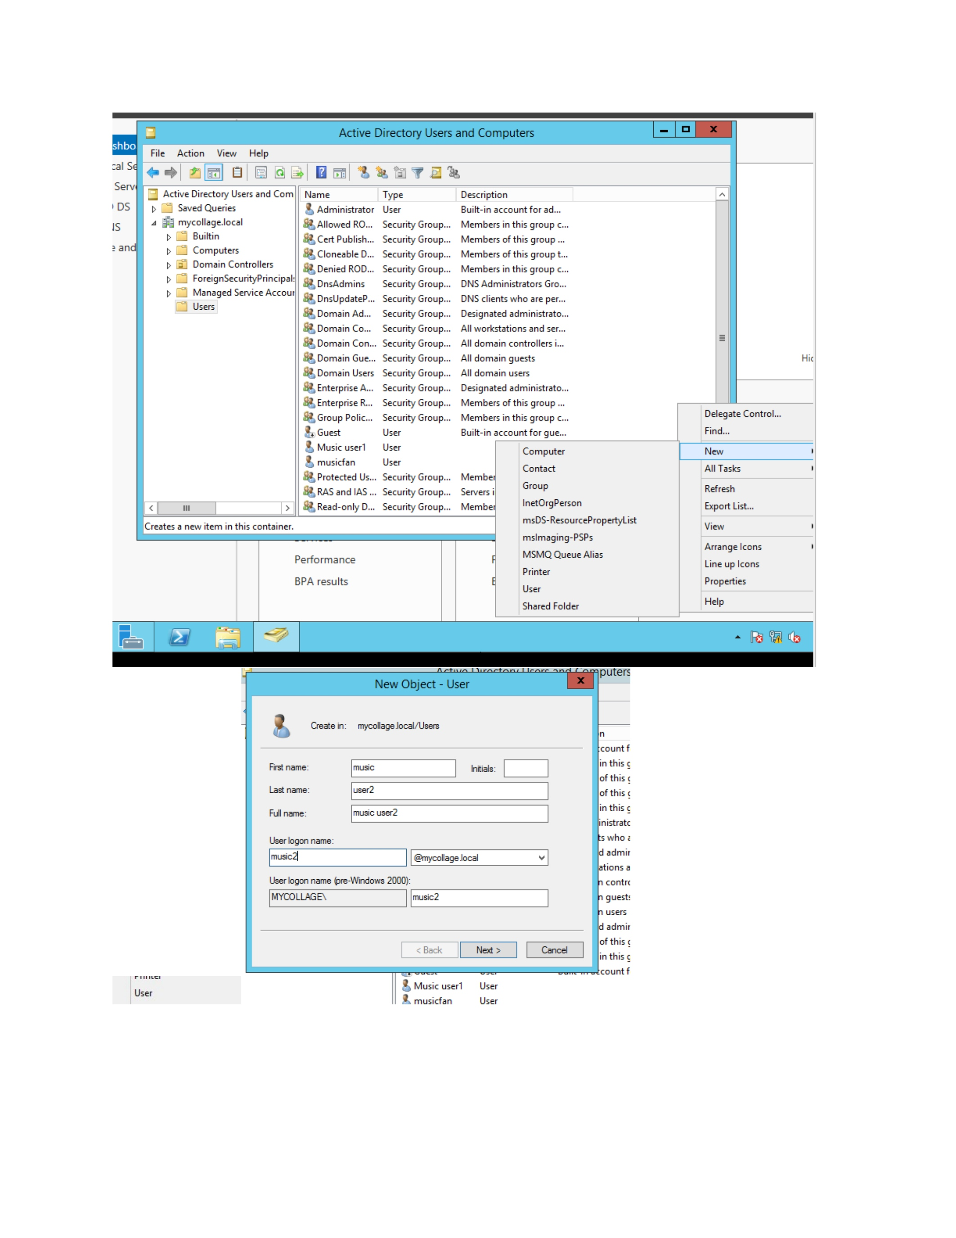
What I did: I configured the account options shown in the New User workflow.
Explanation: These settings control the initial state and password requirements of the new user.

PAGE 12 — ACTIVE DIRECTORY USERS
Topic: Enter user details
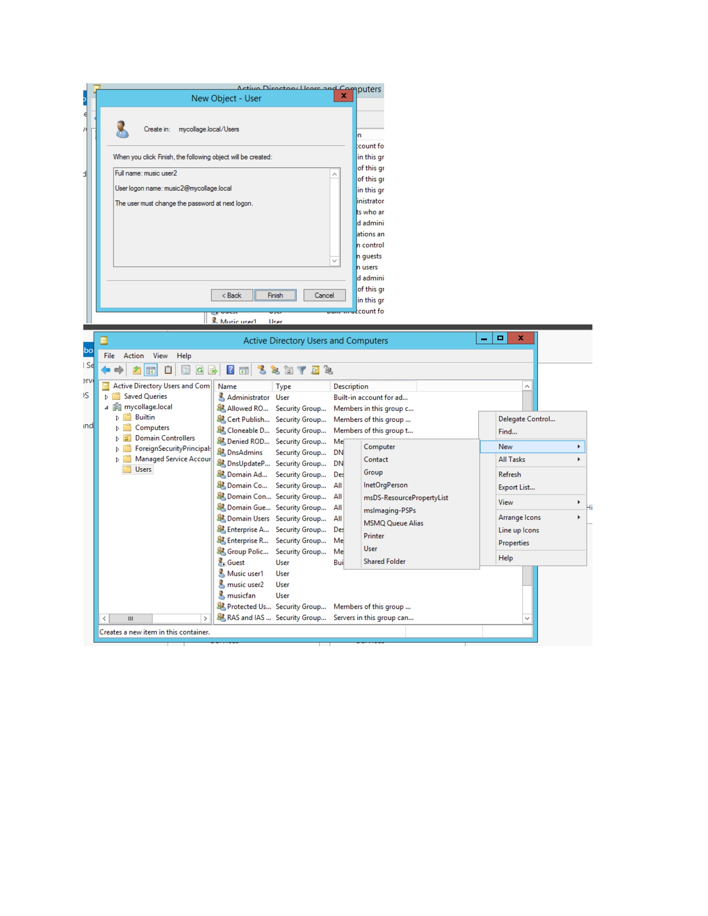
What I did: I entered the user information in the account-creation window.
Explanation: The entered details identify the new user account in Active Directory.

PAGE 13 — ACTIVE DIRECTORY USERS
Topic: Create the user account
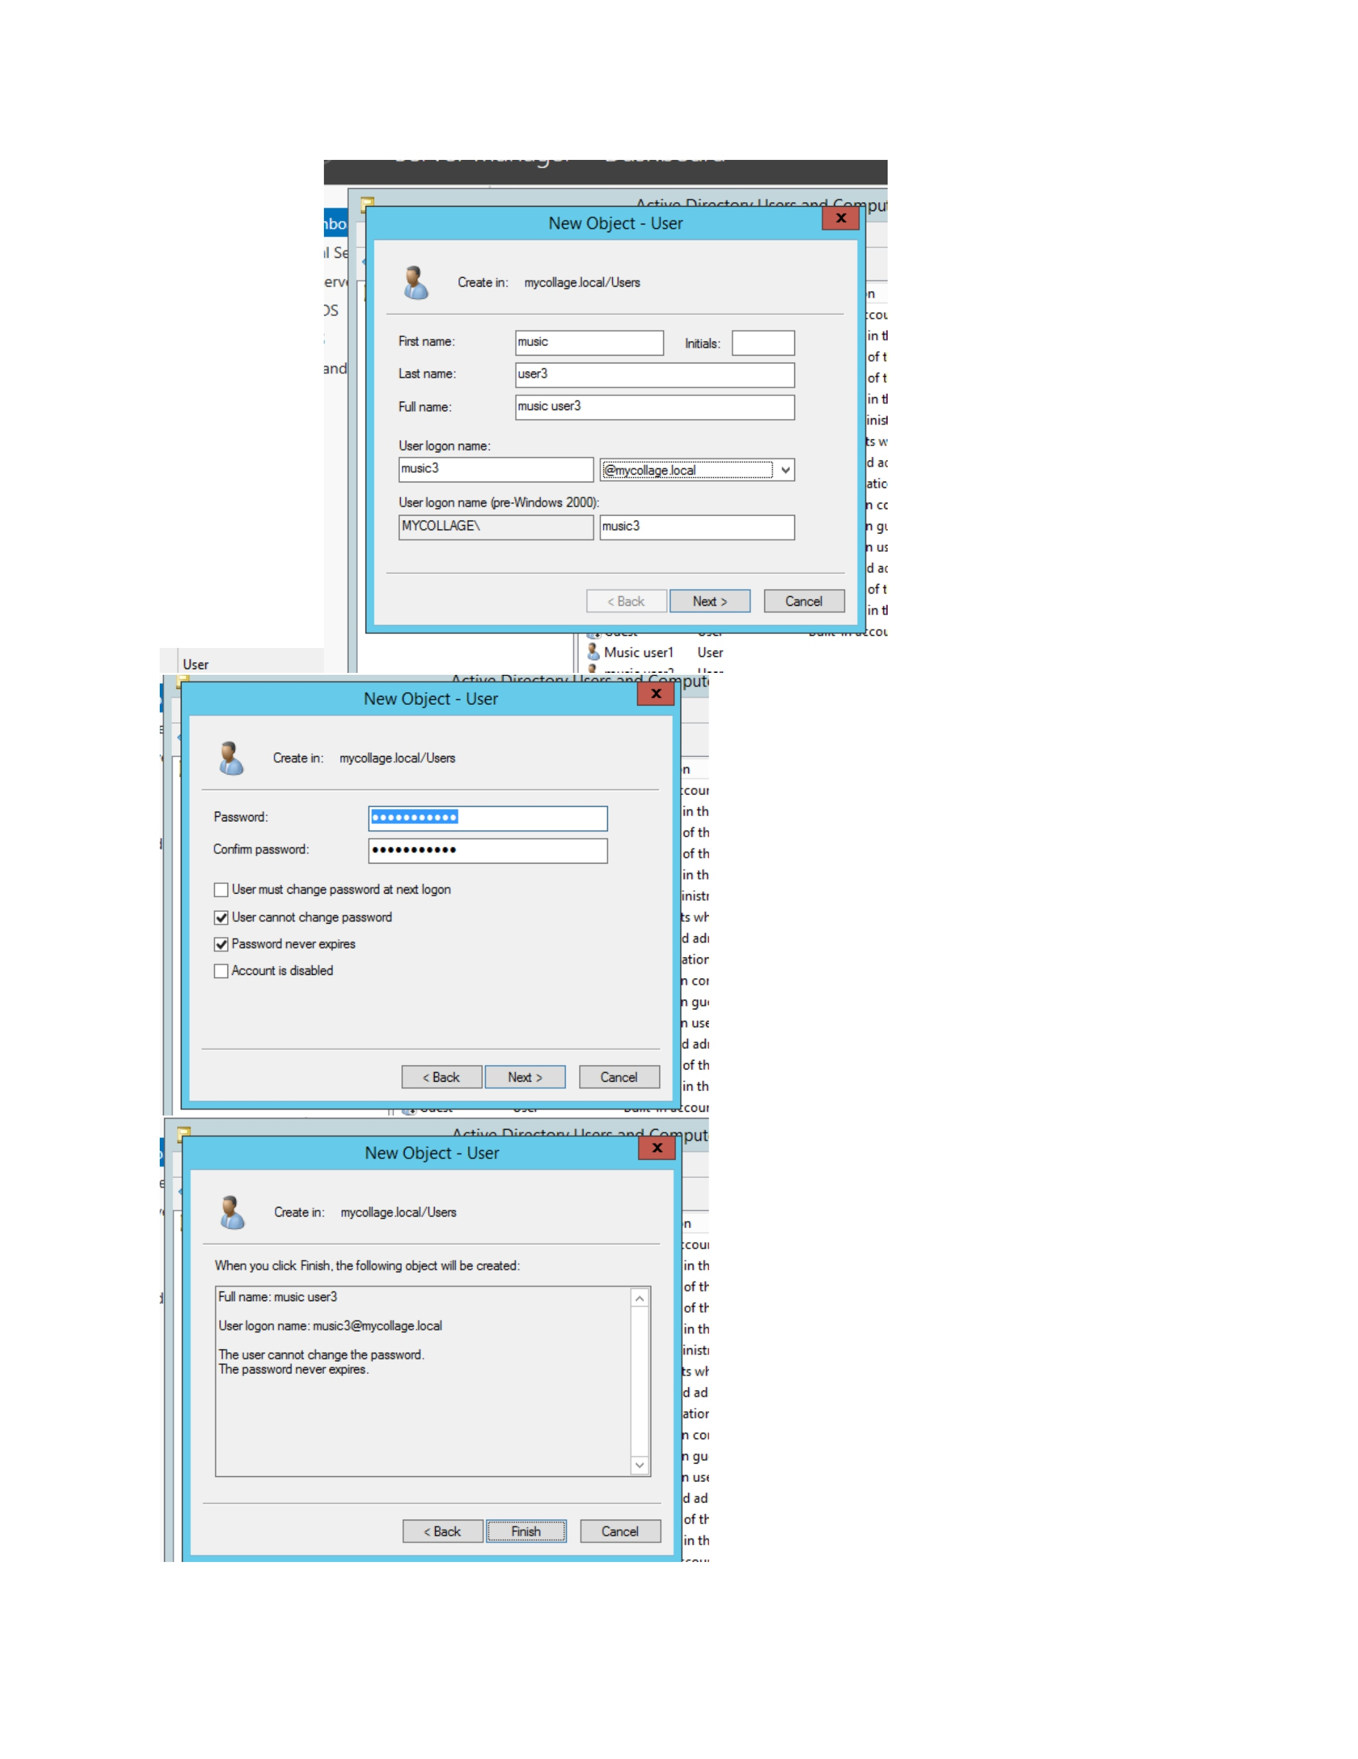
What I did: I completed the New User form and confirmed the account creation.
Explanation: The new user is added to the selected Active Directory container.

PAGE 14 — ACTIVE DIRECTORY USERS
Topic: Create another user
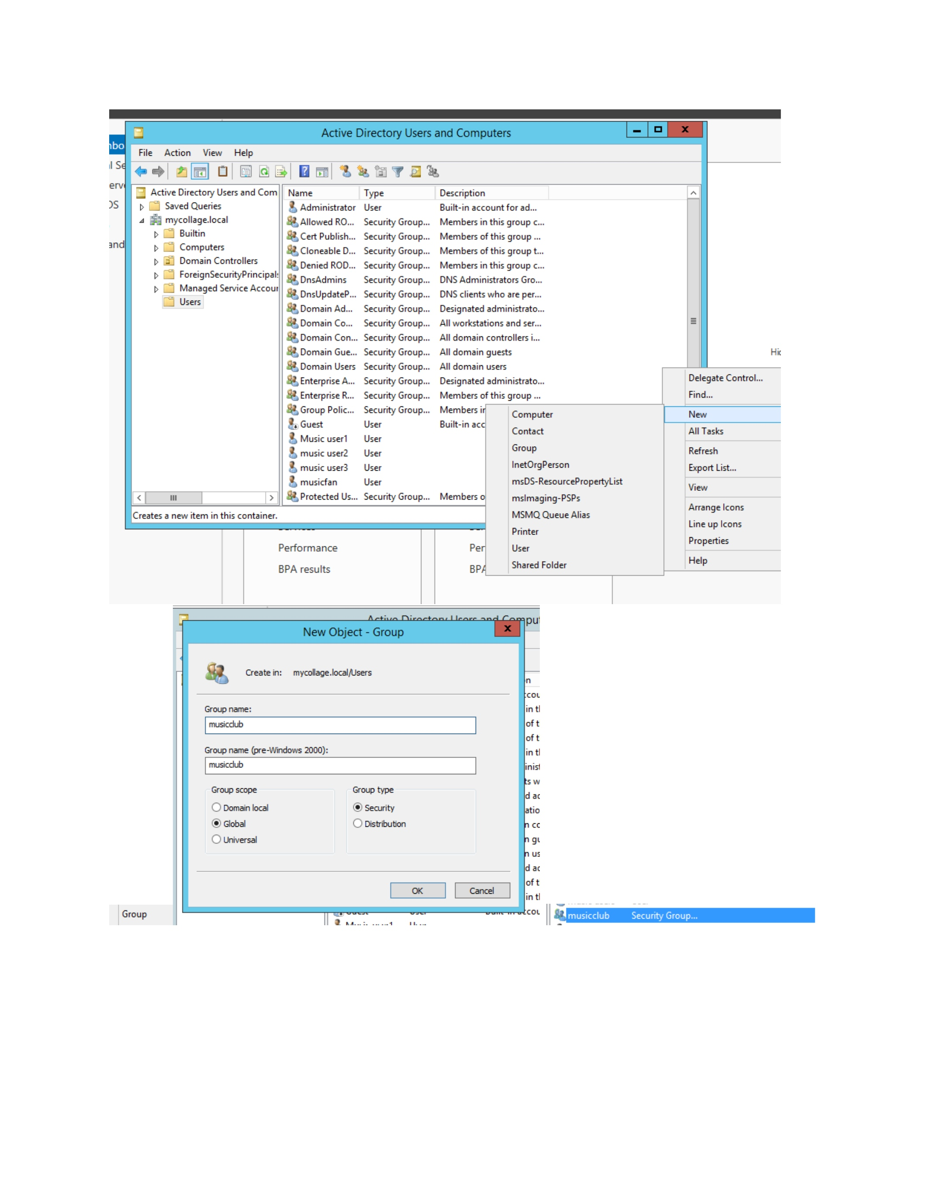
What I did: I opened the user-creation window again and entered the next account details.
Explanation: This creates the additional user required for the practical.

PAGE 15 — ACTIVE DIRECTORY USERS
Topic: Configure the user account
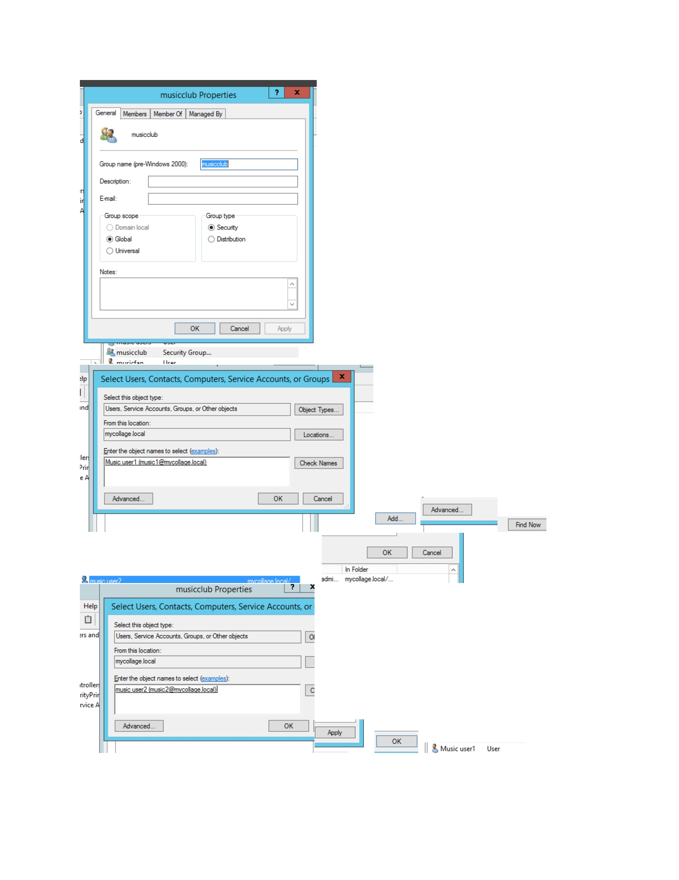
What I did: I reviewed and configured the account settings for the user shown.
Explanation: The account properties are set before completing the user-management task.

PAGE 16 — ACTIVE DIRECTORY USERS
Topic: Review user properties
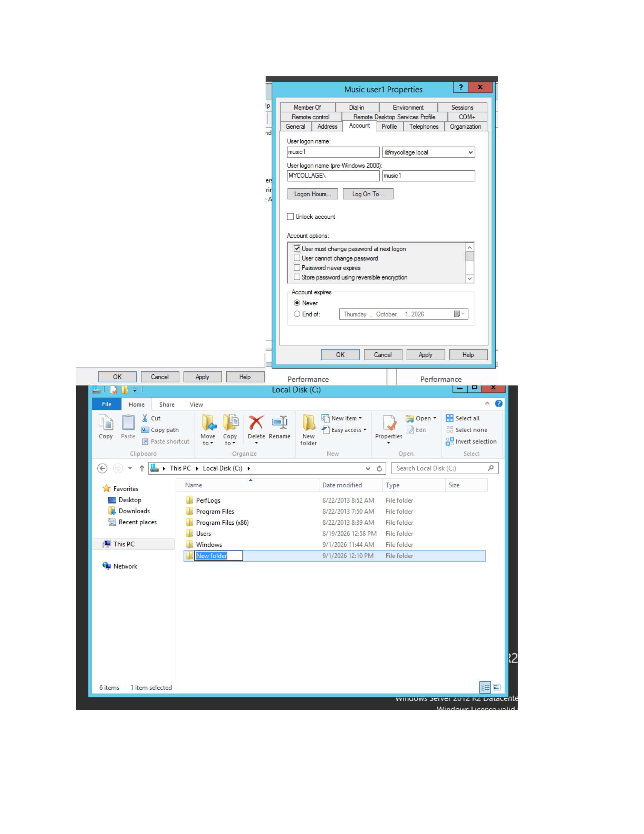
What I did: I opened the user properties and reviewed the available account settings.
Explanation: The properties window provides control over the user's account information and options.

PAGE 17 — FILE SHARING / USER ACCESS
Topic: Open the Windows folder
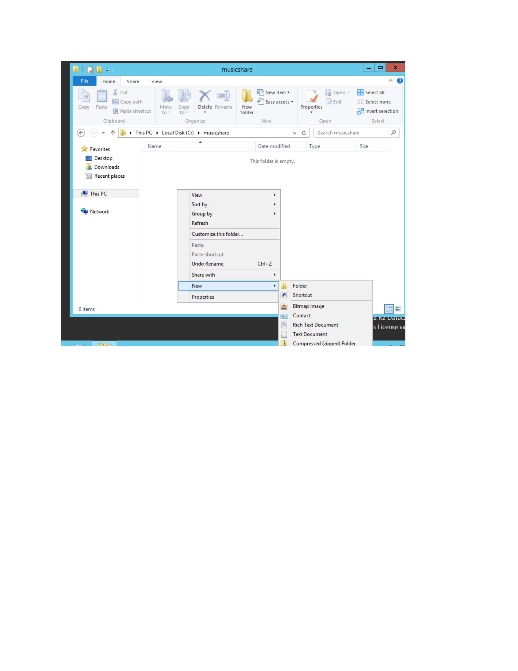
What I did: I opened the folder in Windows Explorer and reviewed its contents.
Explanation: The folder is used for the file-sharing or access-management part of the practical.

PAGE 18 — FILE SHARING / USER ACCESS
Topic: Review folder options
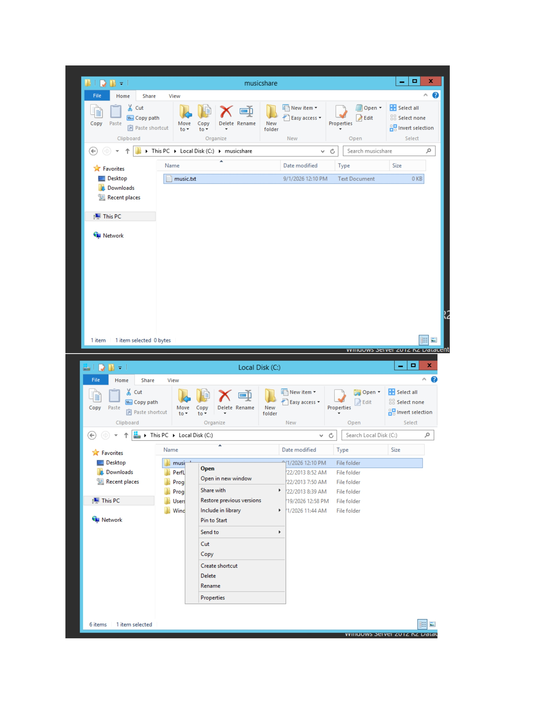
What I did: I opened the folder context menu and reviewed the available management options.
Explanation: The context menu provides access to the folder's sharing and security settings.

PAGE 19 — FILE SHARING / USER ACCESS
Topic: Open folder properties
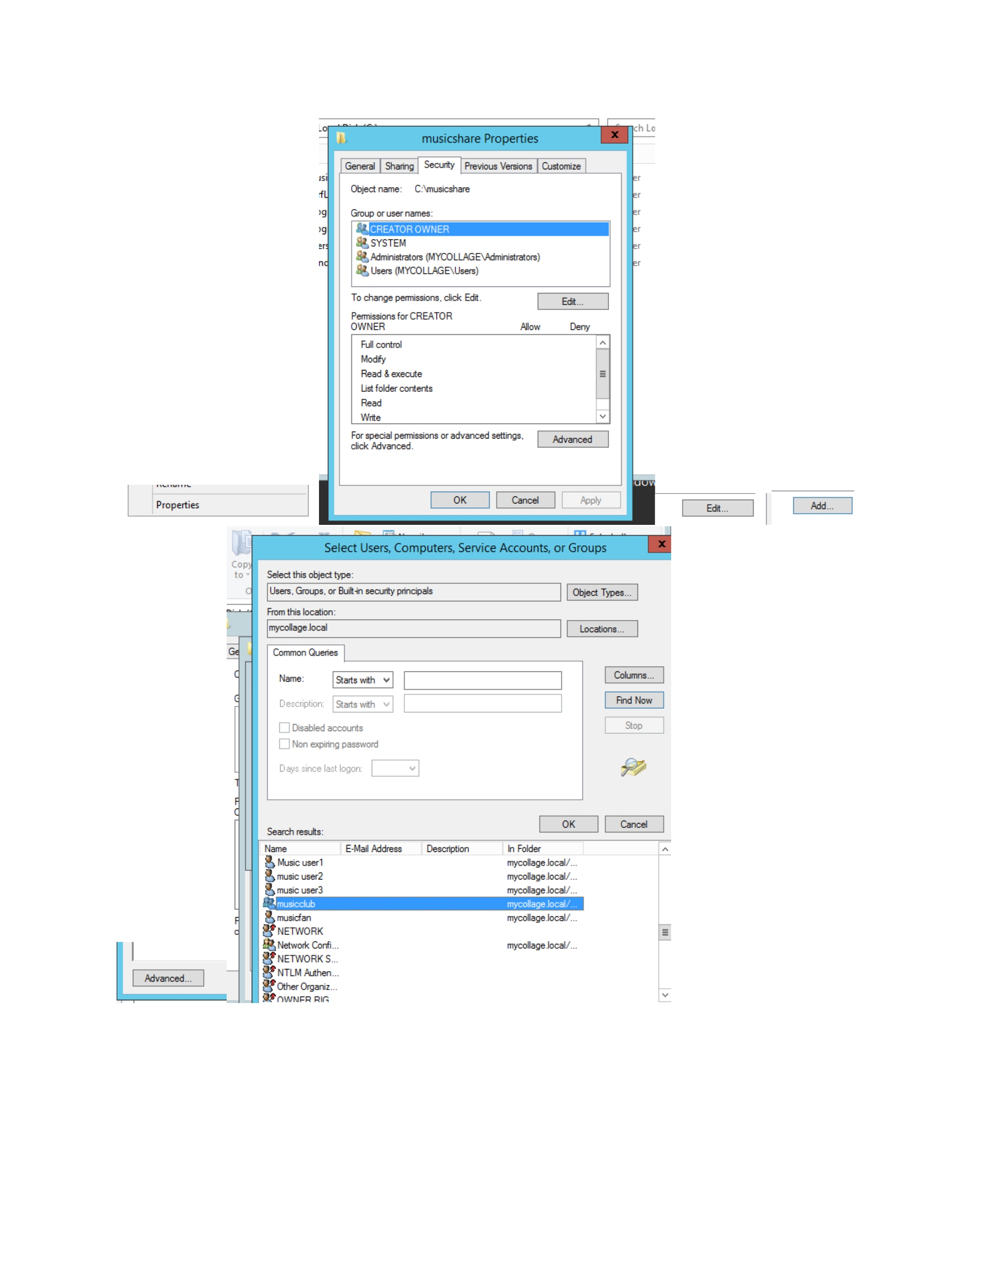
What I did: I opened the Properties window for the selected folder.
Explanation: The Properties window is used to configure sharing and permissions.

PAGE 20 — SHARING
Topic: Configure sharing
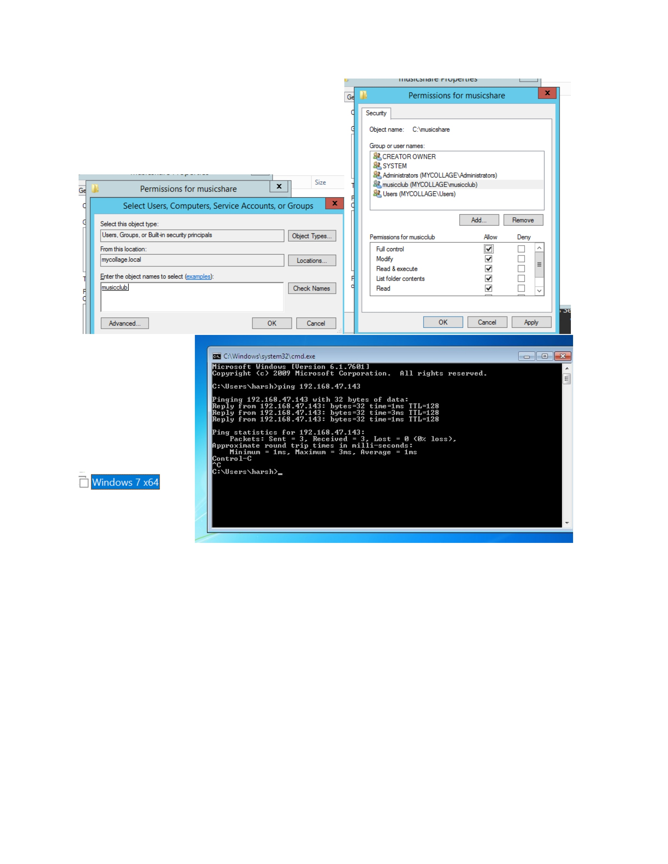
What I did: I opened the sharing configuration for the folder and reviewed the available sharing settings.
Explanation: This step prepares the folder to be shared with the required users.

PAGE 21 — SECURITY
Topic: Review user permissions
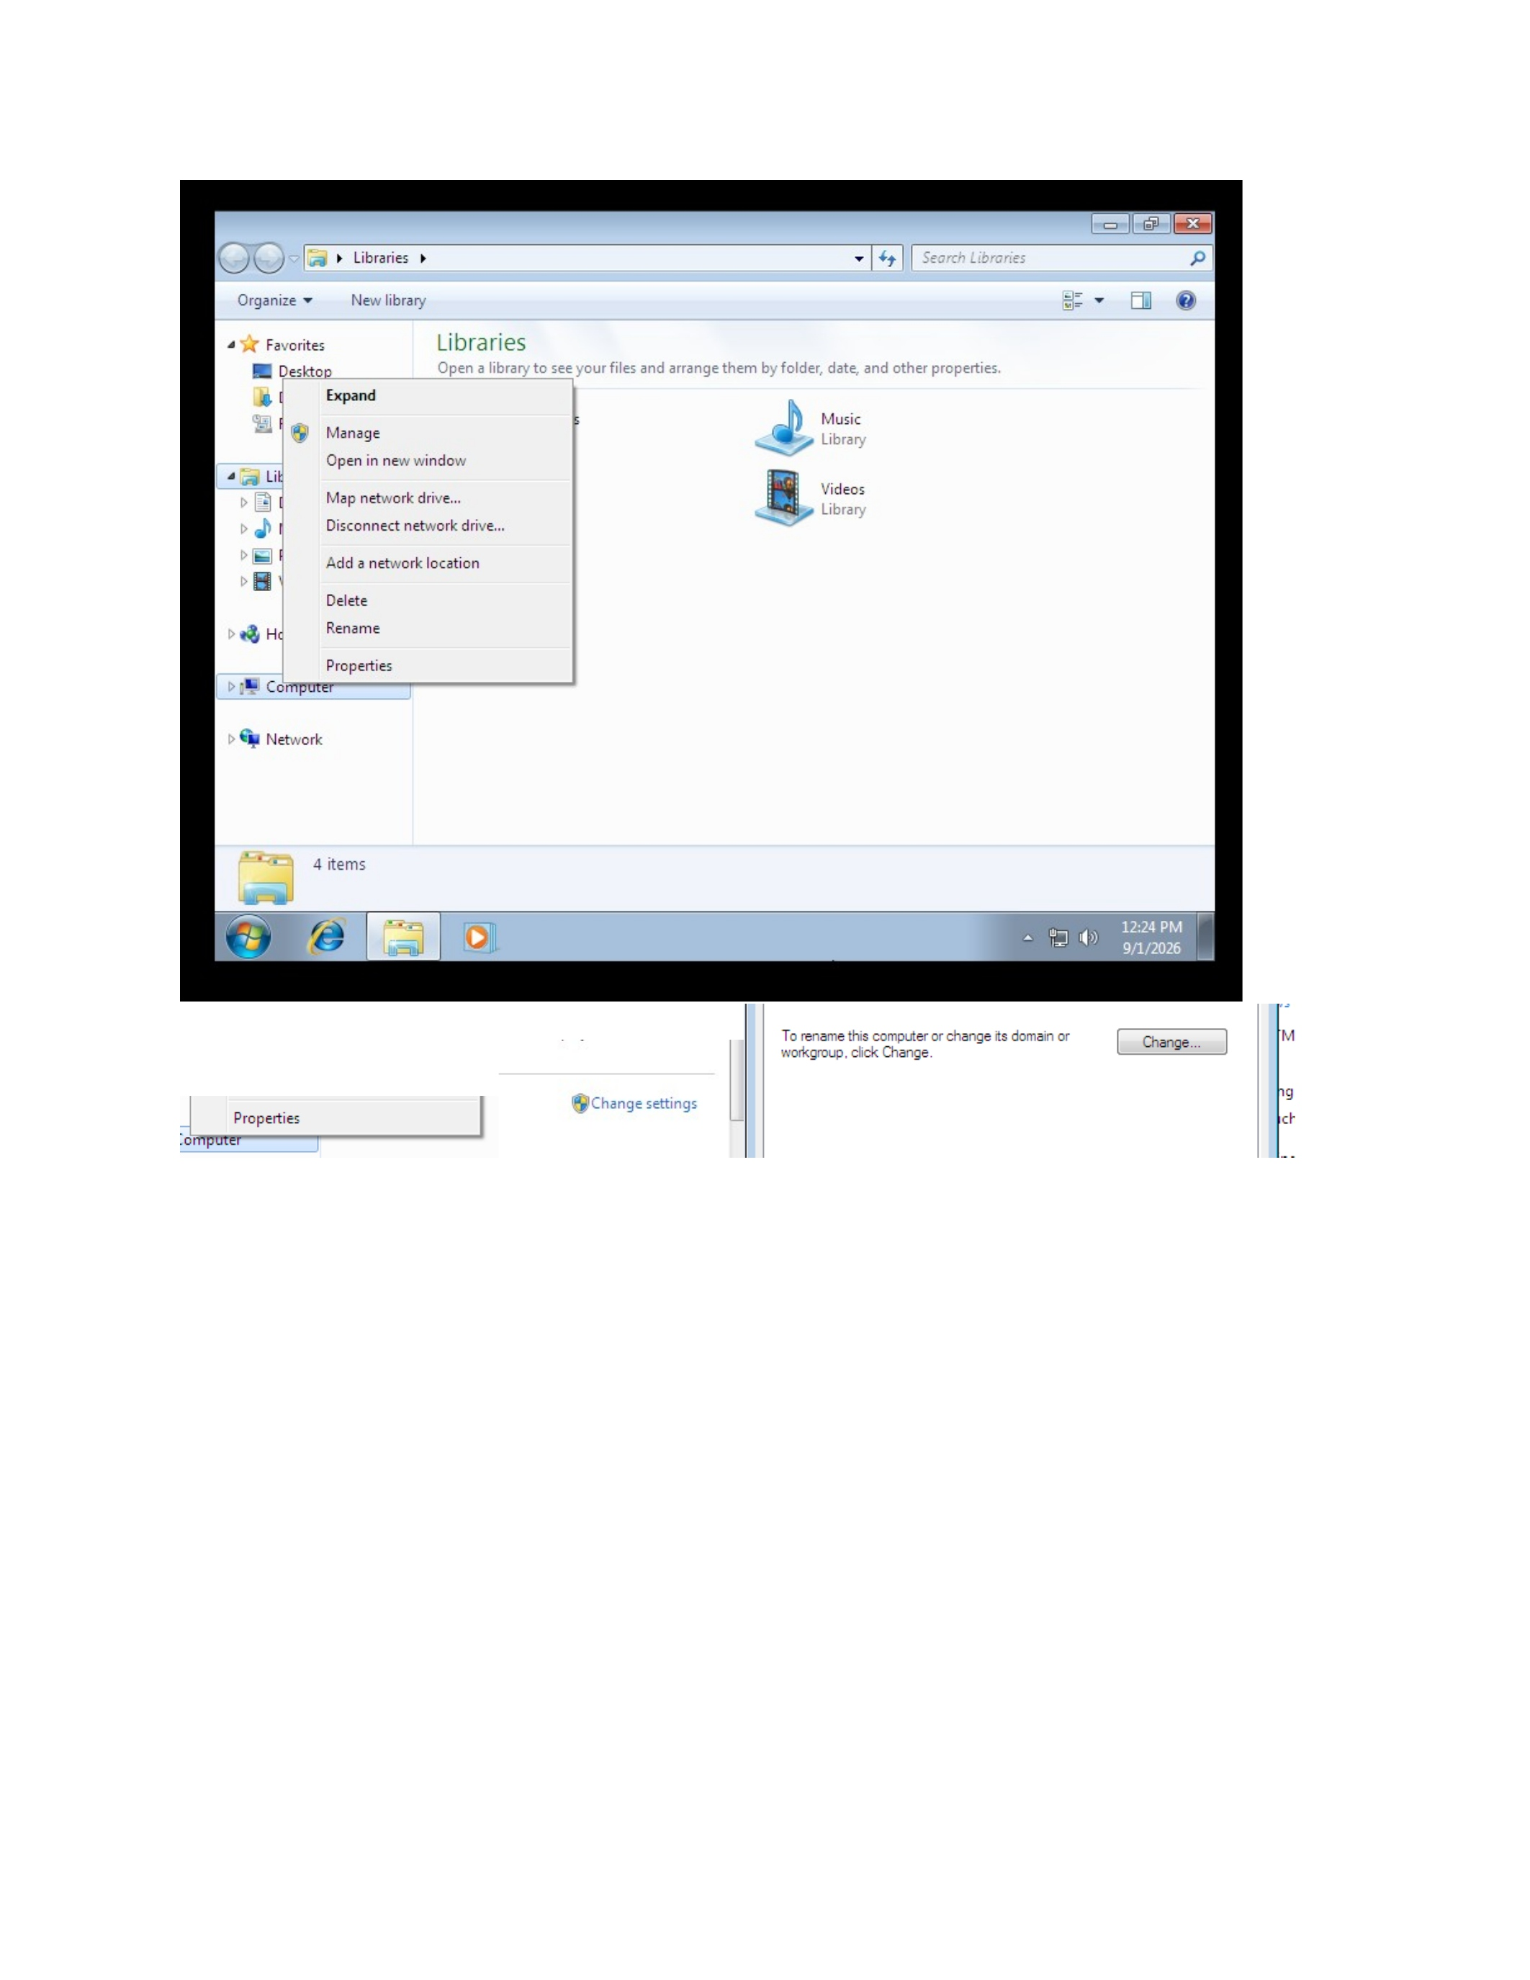
What I did: I reviewed the Security settings and the permissions assigned to the selected user.
Explanation: The permissions determine what the user can do with the shared folder.

PAGE 22 — SECURITY
Topic: Edit permissions
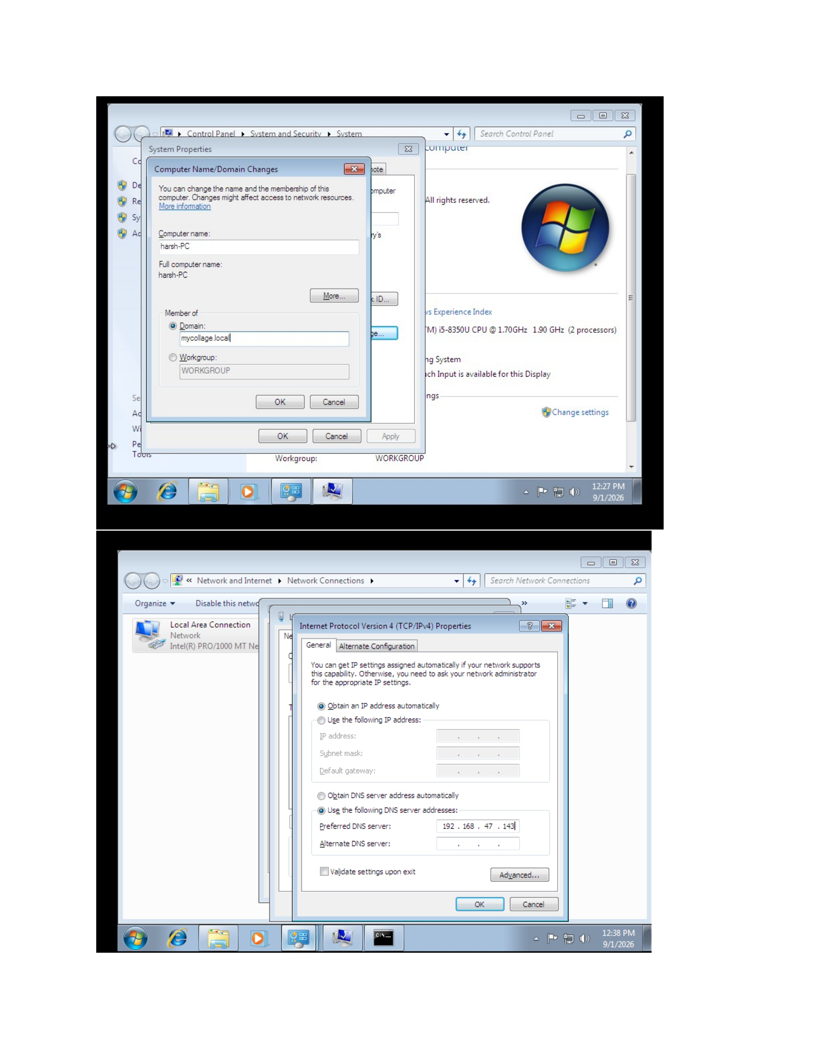
What I did: I opened the permissions editor for the selected user or group.
Explanation: The permissions editor is used to grant or restrict access to the folder.

PAGE 23 — WINDOWS 7 CLIENT
Topic: Open the client system
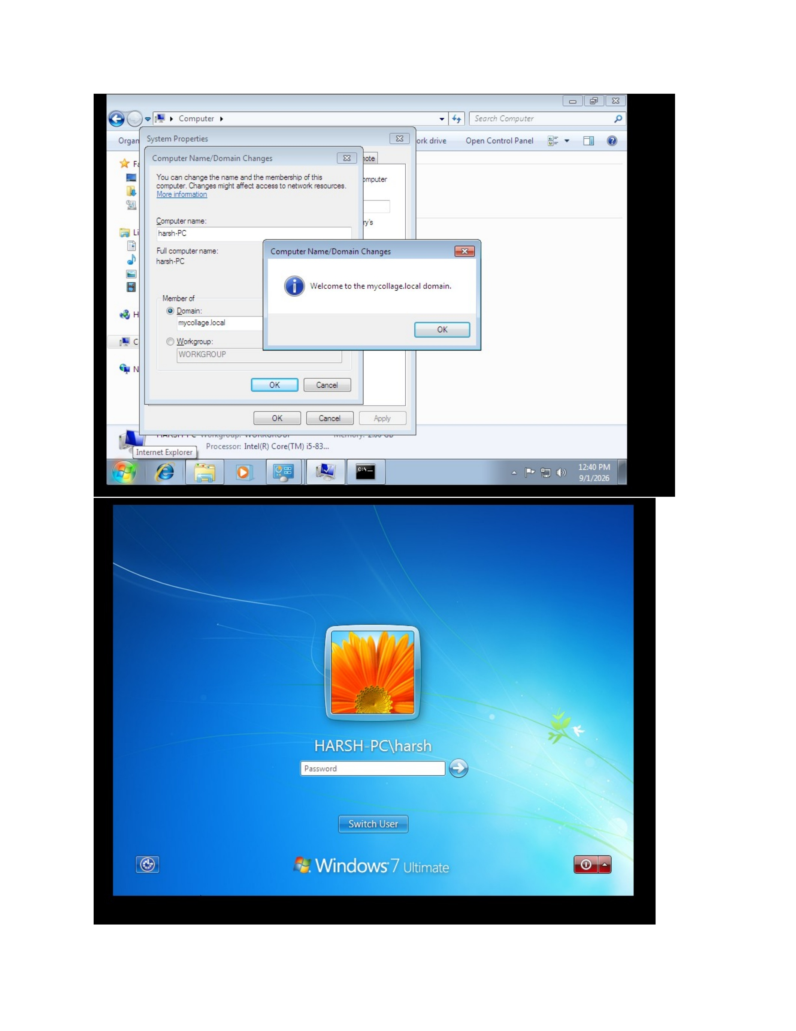
What I did: I switched to the Windows 7 client system to test the configured access.
Explanation: The client system is used to verify that the user can access the configured resources.

PAGE 24 — WINDOWS 7 CLIENT
Topic: Log in to the user account
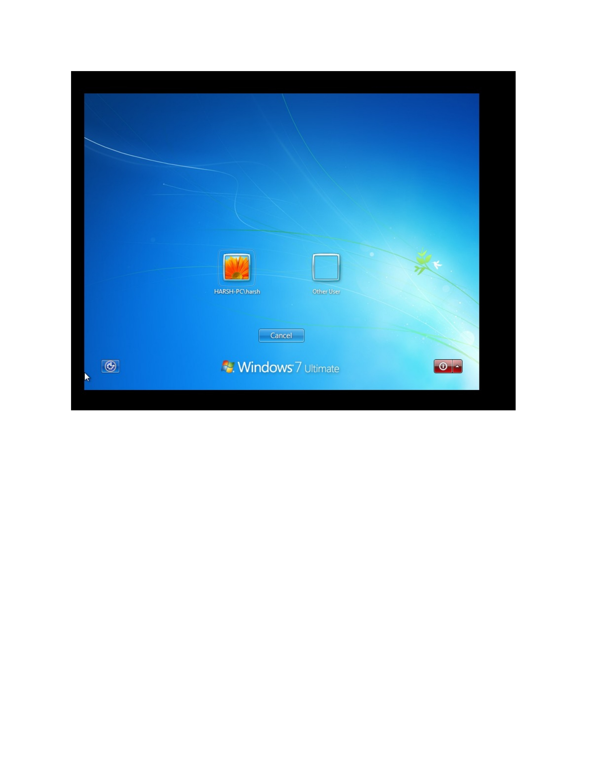
What I did: I logged in to the Windows 7 user account shown on the screen.
Explanation: This starts the access test using the configured user credentials.

PAGE 25 — WINDOWS 7 CLIENT
Topic: Open the network resource
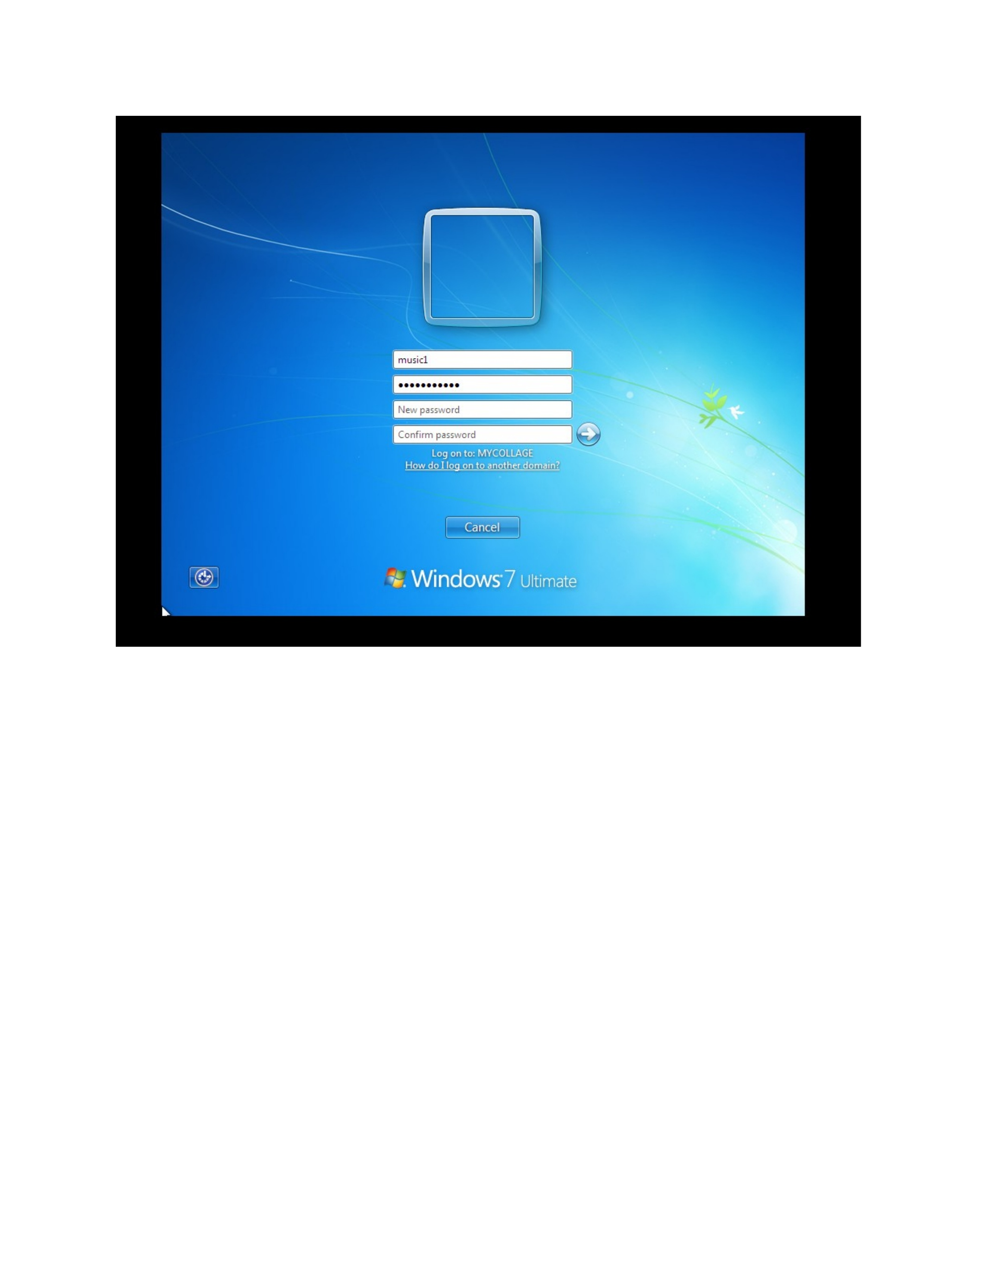
What I did: I opened the Windows environment and navigated toward the configured resource.
Explanation: The client is being prepared to test access to the shared folder.

PAGE 26 — WINDOWS 7 CLIENT
Topic: Review the user environment
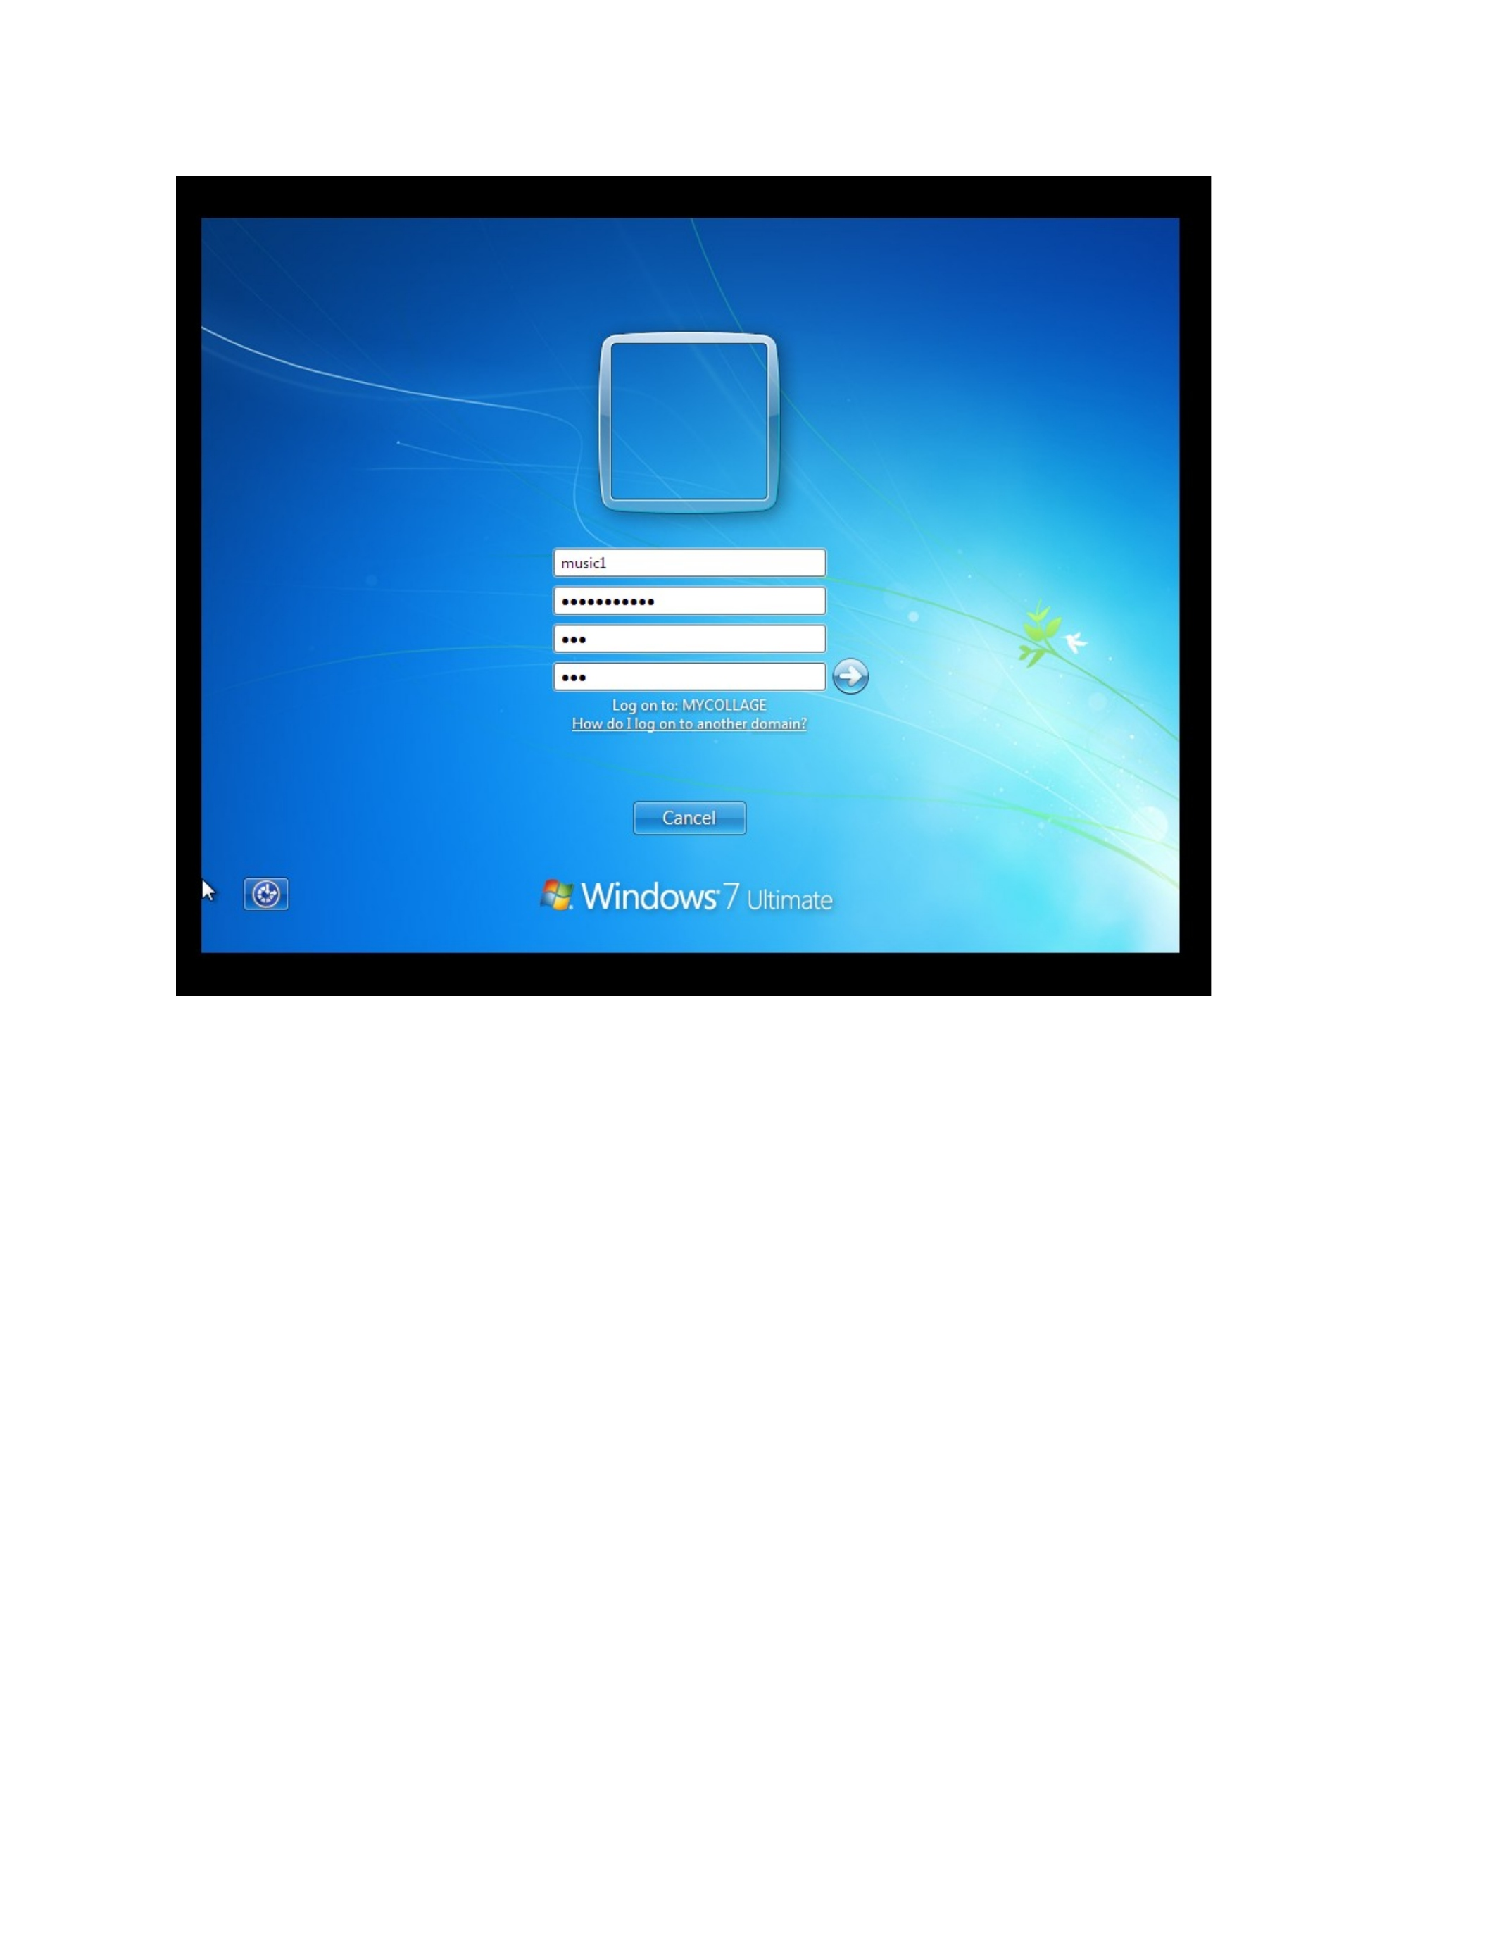
What I did: I reviewed the Windows 7 desktop and available folders after login.
Explanation: This confirms the client-side environment before testing the shared resource.

PAGE 27 — FILE SHARING
Topic: Open the shared folder
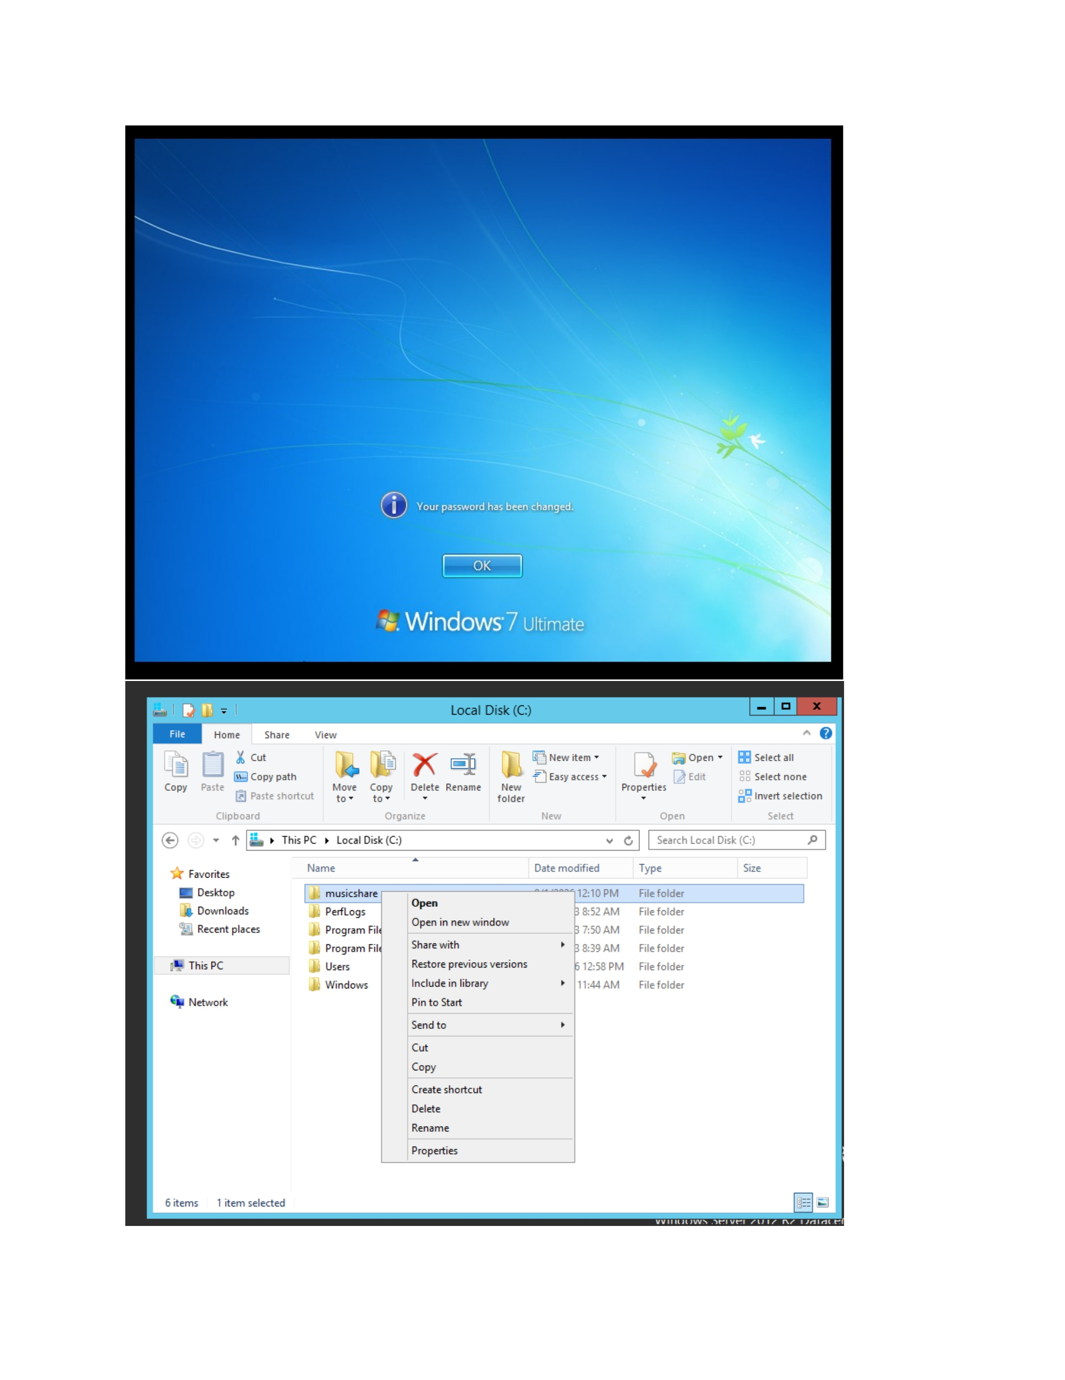
What I did: I opened the shared folder from the Windows client.
Explanation: This tests whether the configured sharing and permissions allow the user to reach the resource.

PAGE 28 — FILE SHARING
Topic: Review the access result
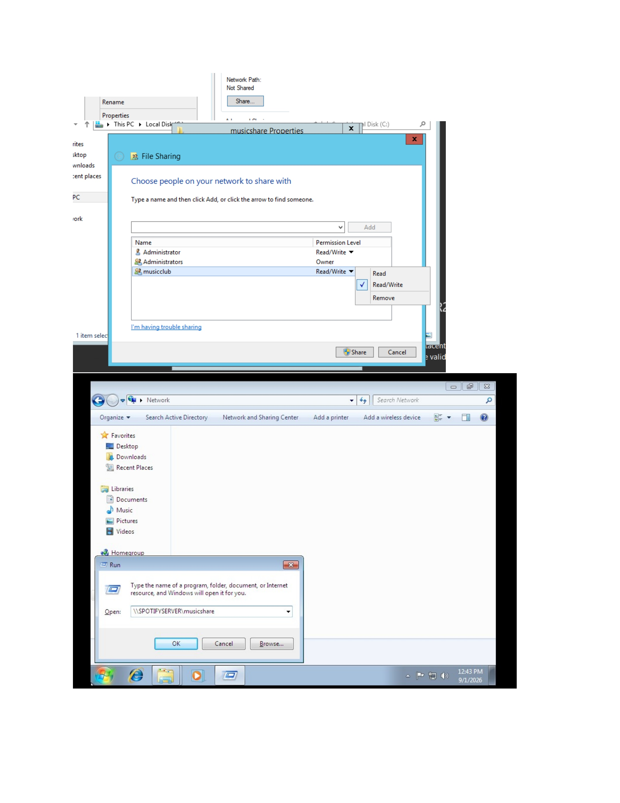
What I did: I checked the folder/access result shown after opening the resource.
Explanation: The result is used to verify that the configured user access is working as intended.

PAGE 29 — WINDOWS 7
Topic: Review system configuration
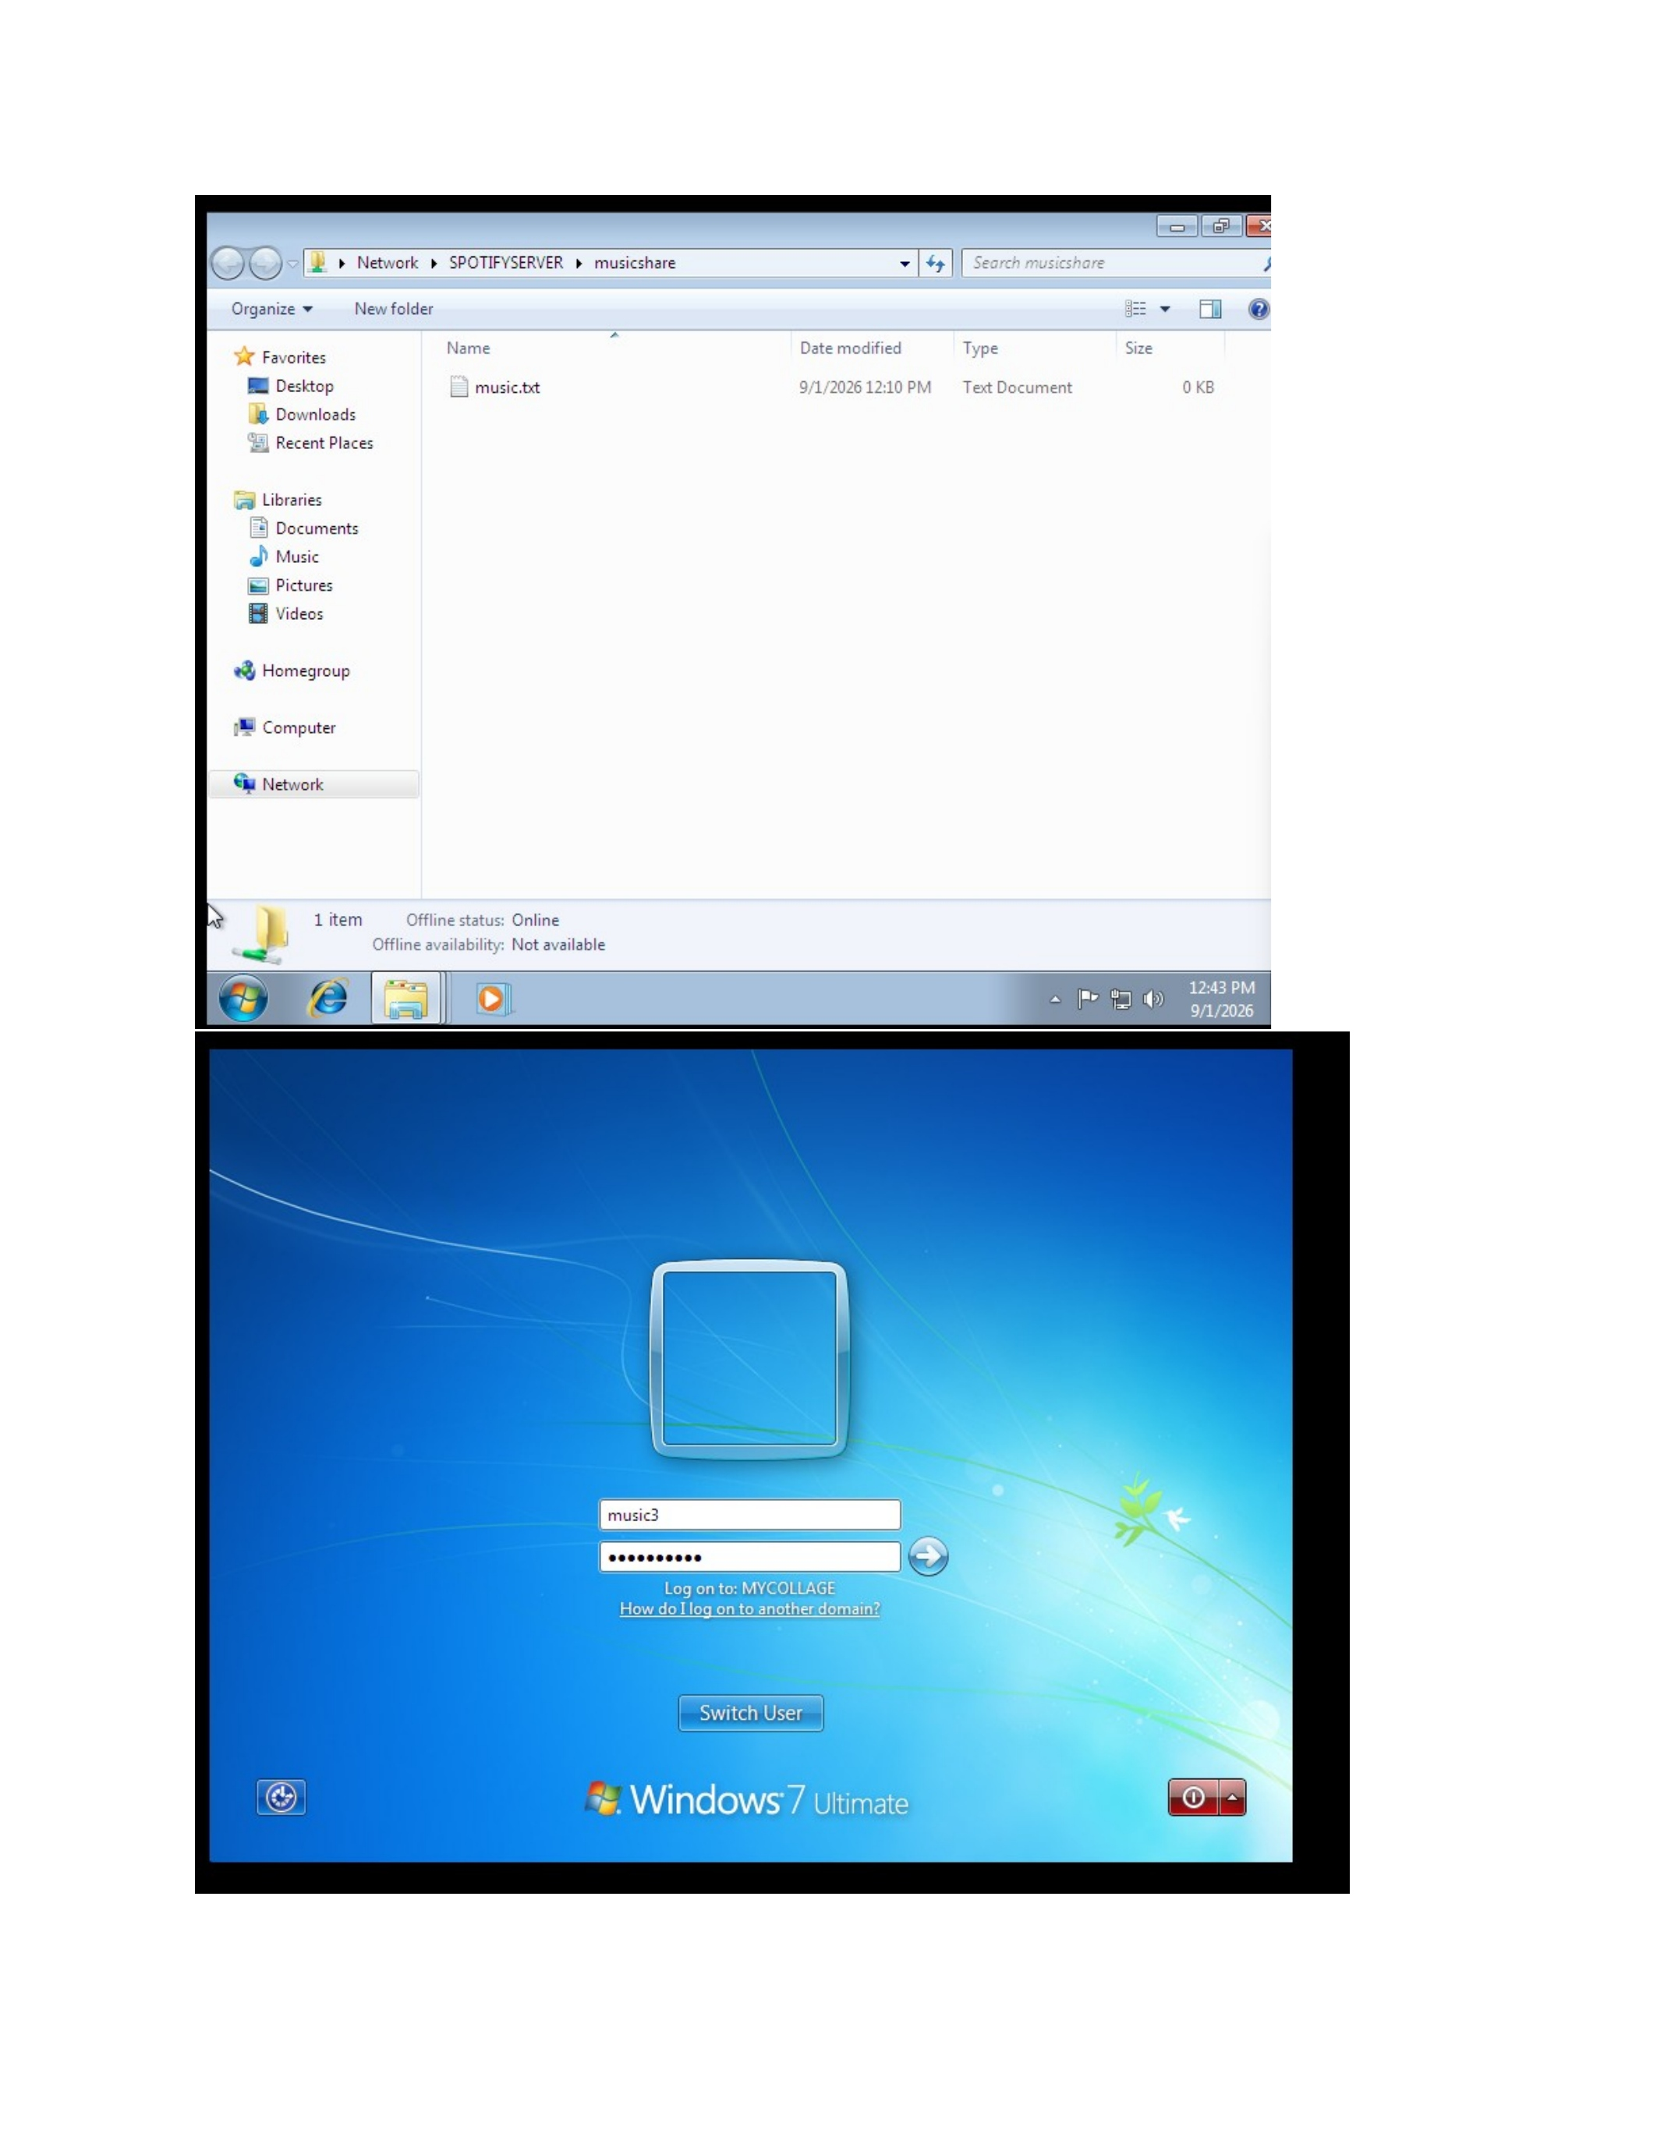
What I did: I reviewed the Windows 7 system and its available configuration settings.
Explanation: This final verification checks the client environment after the user and sharing configuration.

PAGE 30 — WINDOWS 7
Topic: Open the Start menu
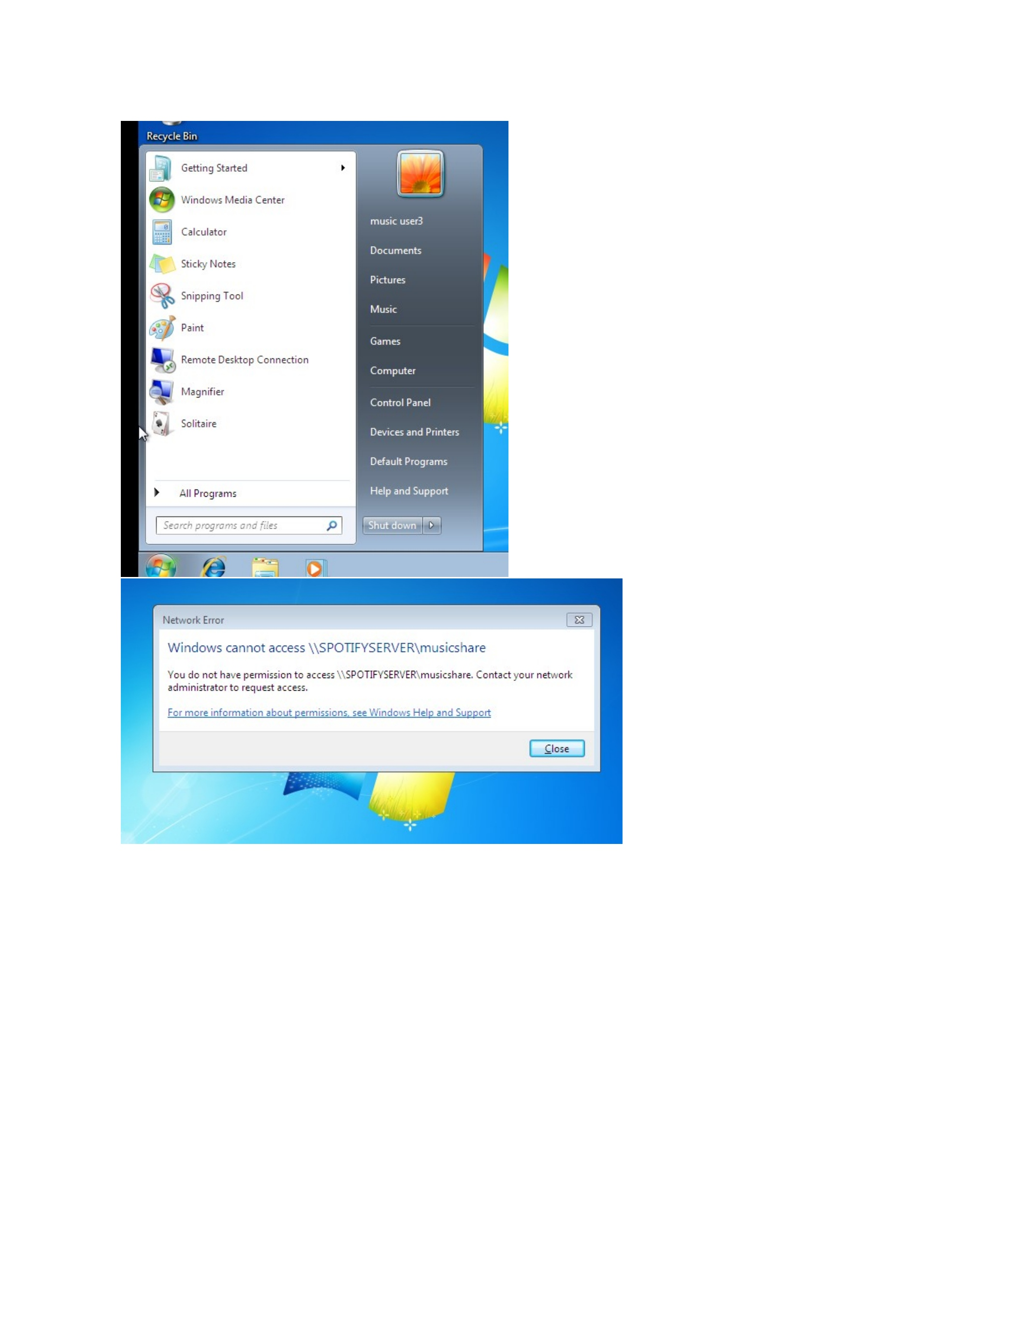
What I did: I opened the Windows 7 Start menu and reviewed the available system options.
Explanation: The system is ready for the final user-management or access verification step.

